Breakfast activity ideas
Introduction

Don’t skip breakfast is one of the Department for Health’s eight tips for healthy eating.
Breakfast is a very important meal because it:
- provides us with energy so we can concentrate, work and be active;
- helps keep us full throughout the morning;
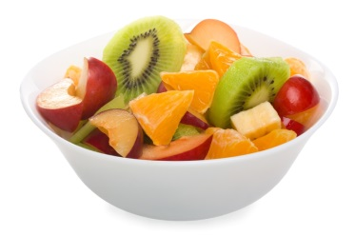
- is a great way to get some of our 5 A DAY, as well as other important nutrients.
Some people skip breakfast because they think it will help them lose weight. However, research shows that eating breakfast can help people control their weight.
Top tips
- Make time for breakfast – just waking up 10 minutes earlier so you have time for something to eat and drink can make a big difference to your day.
- Try something new – a sandwich might seem like a strange choice but the key is to establish a regular pattern of eating breakfast.
- Go for variety – try different types of bread such as bagels, fruit loaf, hot cross buns, crumpets or English muffins.
- Have a drink – go for water, fruit juice, fruit smoothies or milk to keep you well hydrated.
- Have some fruit – start your 5 a day with some fruit on cereal, fruit juice or a mashed banana on toast.
- Choose wholegrain varieties - wholegrain cereals and bread provide fibre which helps maintain a healthy digestive system.
- Include some calcium – milk and dairy foods are sources of calcium which is needed for strong bones and teeth.
- Include some protein – try baked beans or lean grilled bacon. Protein helps support growth and repair of muscles.

- Cut down on foods and drinks high in fat, sugar and/or salt –have foods such as pastries, pancakes and croissants occasionally.

- On the go – choose something quick and easy such a couple of pieces or fruit or make a sandwich the night before to take with you.

