Breakfast cereal line up

Breakfast cereal line up – Teachers’ notes

In this activity, pupils put boxes of cereal in order by their fibre content per 100g. Pupils then repeat the task and put the cereals in order by the total sugars per 100g. Pupils who put the cereal boxes in the correct order can pull a prize out of a prize bag, e.g. box of wholegrain cereal.
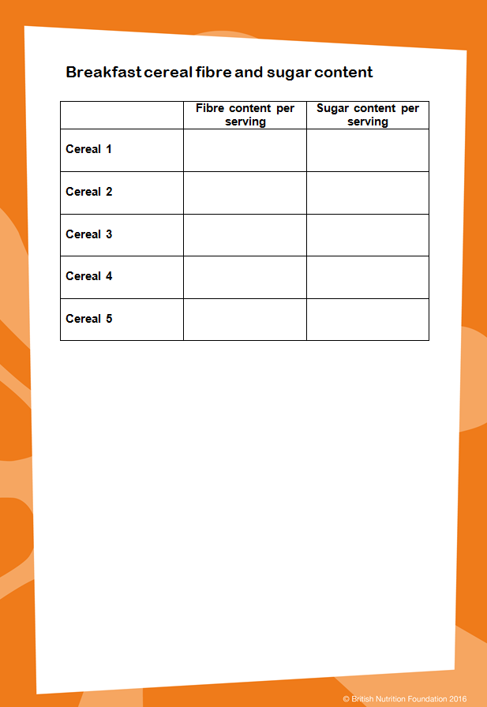
Equipment:
- selection of breakfast cereal boxes (around five);
- sticky labels;
- scissors;
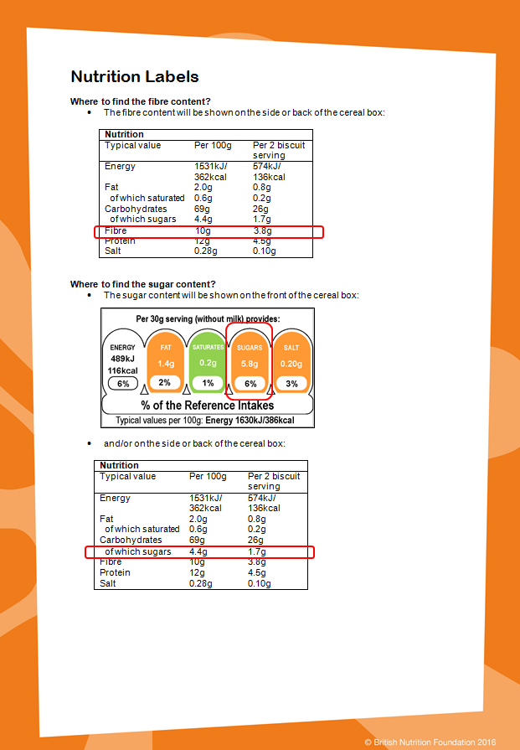
- sticky tape.

Instructions:
- Choose five cereals for the line-up. Try to choose cereals which contain a broad range of fibre and sugar (You will be able to find the fibre and sugar content on the nutrition label which will be located on the side or back of the box. The document ‘nutrition labels’ provided in this pack explains where to find the fibre and sugar content.).
- Write down the fibre and sugar content in the table (provided in this pack) for you to reference when assessing if the pupils have put the cereal boxes in the correct order.
- Cover any nutrition claims that are on the box, (e.g. high in fibre), the front of pack nutrition label and back of pack nutrition label with a sticky label.
- Put your selection of breakfast cereals out in a random order.
- To start the activity, ask pupils to put the boxes of cereal in order of the fibre content.
- Once they have done this, reveal if they are correct.
- Ask them to repeat the task by putting the boxes of cereal in order of the sugar content.
- Reveal if they are correct.
- If pupils put the boxes of cereal in the correct order both times, allow them to pull a prize out of a prize bag.
- Rearrange the cereal boxes before other pupils take part in the activity so the boxes are in a random order.
- Invite other pupils to take part in the activity.

Breakfast cereal line up

Rules

- Put the boxes of cereal in order of the fibre content.

- Afterwards, put the cereal boxes in order of the sugar content.

- If you put the boxes in the correct order both times, you could win a prize.

Breakfast cereal line up
Table of fibre and sugar content of different breakfast cereals

 | Fibre content per 100g | Sugar content per 100g
Cereal 1
Cereal 2
Cereal 3
Cereal 4
Cereal 5

Breakfast cereal line up
Nutrition Labels

Where to find the fibre content?
- The fibre content will be shown on the side or back of the cereal box:

Nutrition
Typical value | Per 100g | Per 2 biscuit serving
Energy | 1531kJ/ | 574kJ/
 | 362kcal | 136kcal
Fat | 2.0g | 0.8g
of which saturated | 0.6g | 0.2g
Carbohydrates | 69g | 26g
of which sugars | 4.4g | 1.7g
Fibre | 10g | 3.8g
Protein | 12g | 4.5g
Salt | 0.28g | 0.10g

Where to find the sugar content?
- The sugar content will be shown on the front of the cereal box:
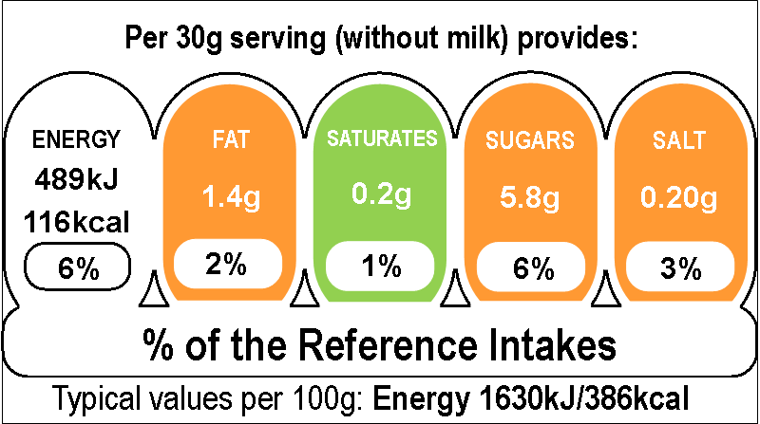

- and/or on the side or back of the cereal box:

Nutrition
Typical value | Per 100g | Per 2 biscuit serving
Energy | 1531kJ/ | 574kJ/
 | 362kcal | 136kcal
Fat | 2.0g | 0.8g
of which saturated | 0.6g | 0.2g
Carbohydrates | 69g | 26g
of which sugars | 4.4g | 1.7g
Fibre | 10g | 3.8g
Protein | 12g | 4.5g
Salt | 0.28g | 0.10g

