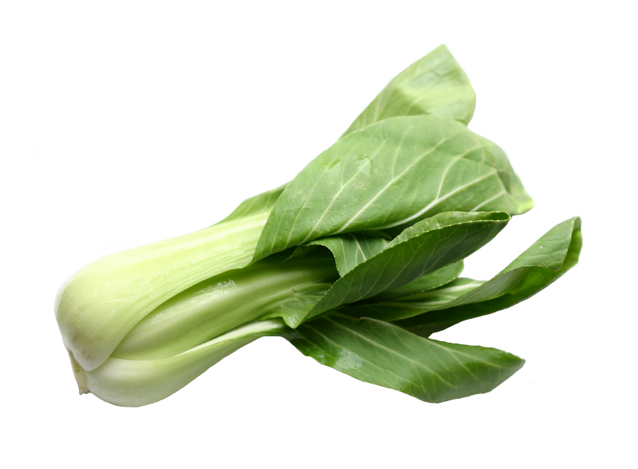
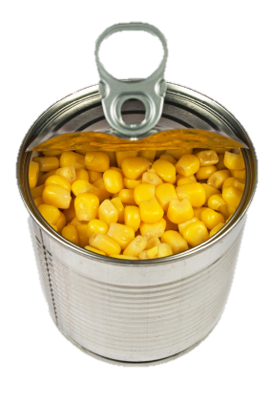
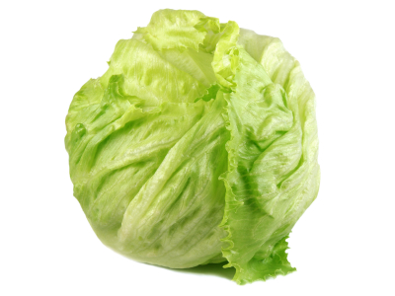
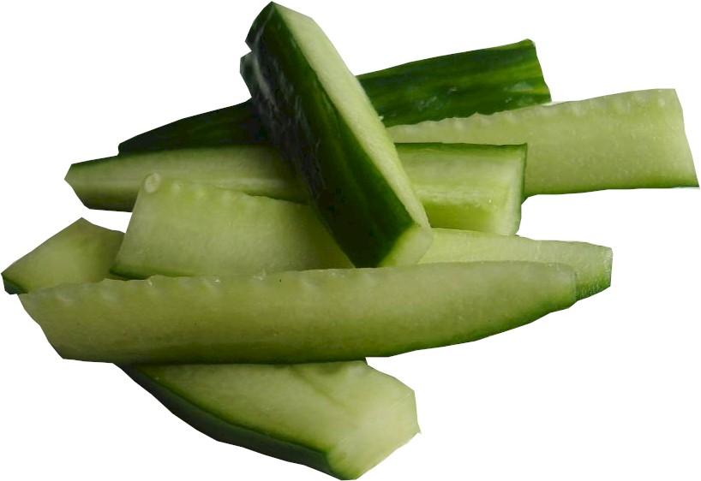
4 heaped 15 ml spoons of lettuce

3 heaped 15ml spoons of canned sweetcorn
4 heaped 15ml spoons of steamed pak choi
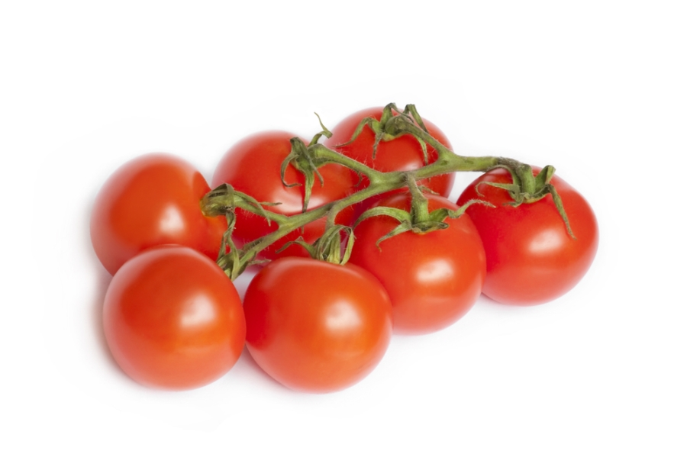
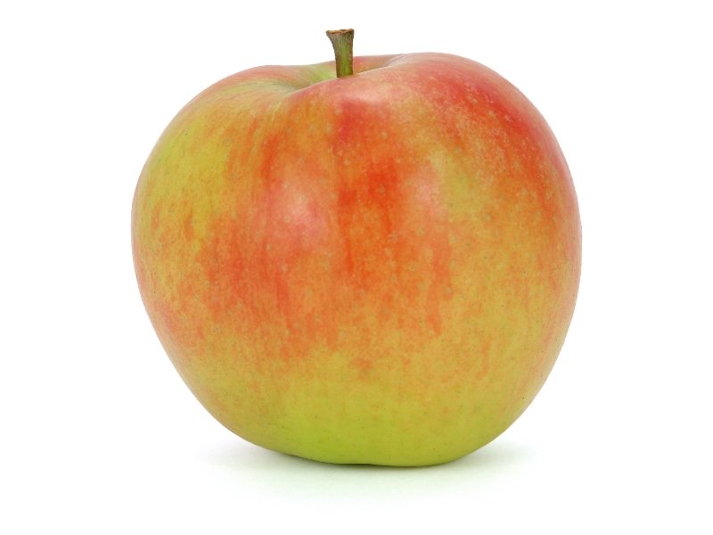
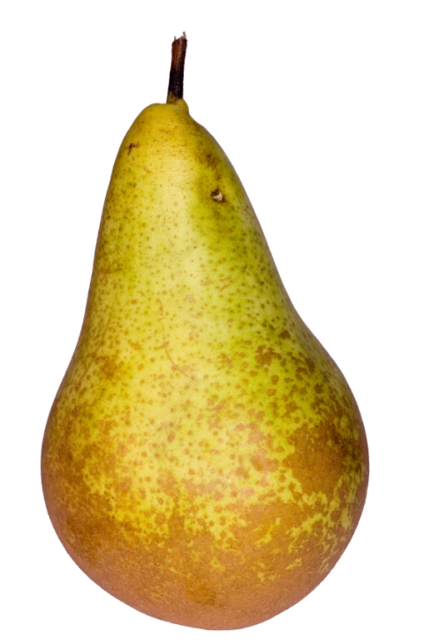

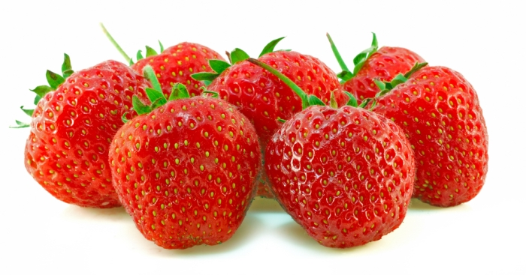
7 strawberries
I medium sized apple (skin and flesh)
1 medium sized apple (skin and flesh)
1 medium sized apple (skin and flesh)
1 medium sized pear (skin and flesh)
7 cherry tomatoes
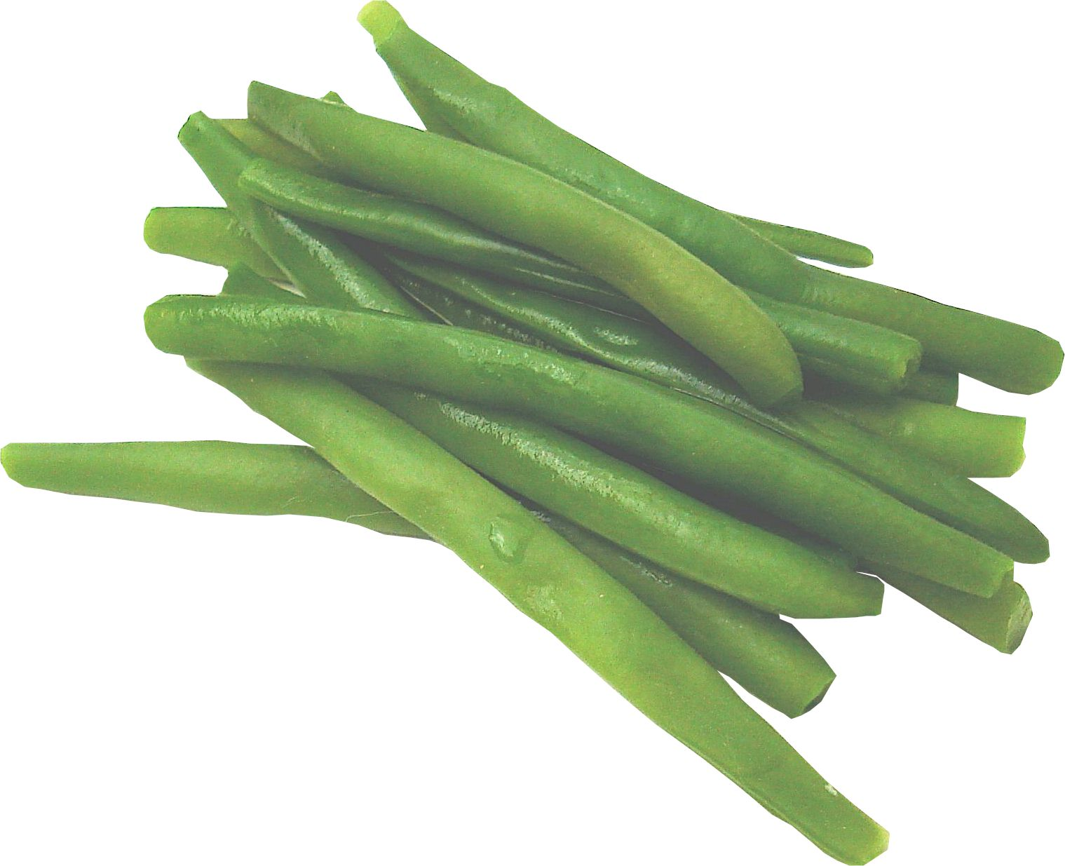
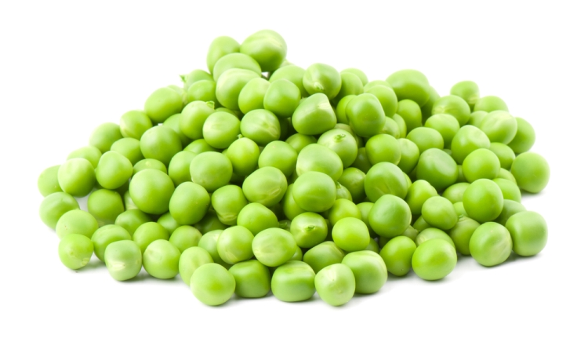
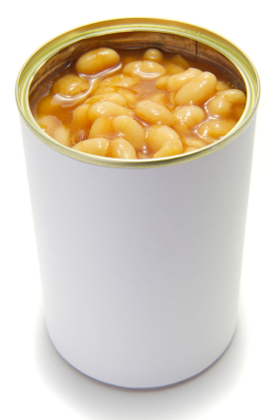
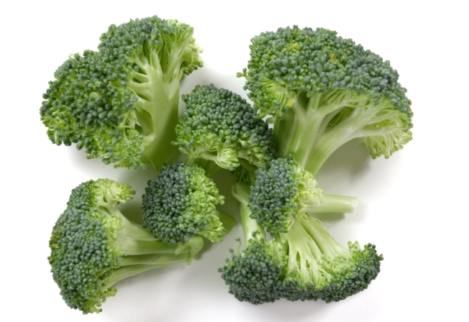
4 heaped 15ml spoons of boiled green beans
3 heaped 15ml spoons of peas (frozen and microwaved)
3 heaped 15ml spoons of peas (frozen and microwaved)
3 heaped 15ml spoons of baked beans (reduced salt)
2 spears of steamed broccoli

0.96g

0.56g

1.2g

1.04g

2.16g

1.6g

2.48g

3.04g

3.28g

3.04g

4.48g

3.92g

