Guess the fibre content

Guess the fibre content –
Teachers’ notes

In this activity, pupils try to match a selection of fruit and vegetables to the amount of fibre they contain. Pupils who correctly match the fibre content and fruit or vegetable can pull a prize out of a prize bag, e.g. bag of dried apricots.

Equipment:
- cards (provided in this pack);
- scissors;
- laminator (if you wish to laminate the cards).
Instructions
- Cut out the cards and laminate them.
- Lay four fruit and vegetable picture cards on one side of the table and the cards stating their fibre content on the other side.
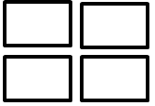
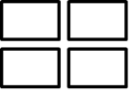

- To start the activity, invite pupils to begin matching the fruit and vegetable cards to the fibre content cards.
- The pupils who correctly match all the cards can pull a prize out of a prize bag, e.g. a bag of dried apricots.
- Shuffle the cards and set out a new selection before the next pupil plays the game.

Ways to adapt this game
- Instead of using the fruit and vegetable picture cards, you could use real fruit and vegetables.
- Set pupils a time limit.
- Increase or reduce the number of cards.

Note: the fibre content is given per 80g and the fruit and vegetable portions stated are an approximate 80g portion.

Guess the fibre content

Rules
- On the table are cards showing portions of fruit and vegetables.
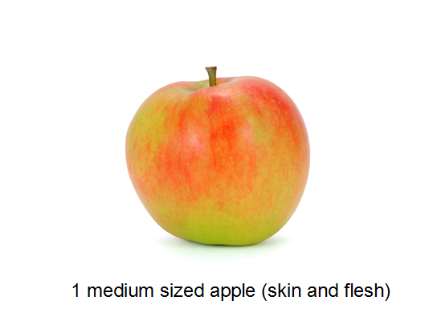
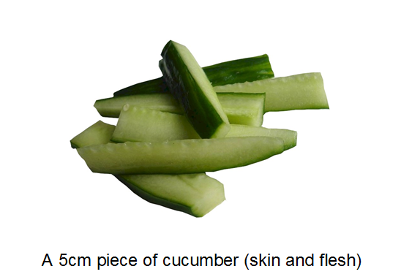

- There are also cards showing grams of fibre.
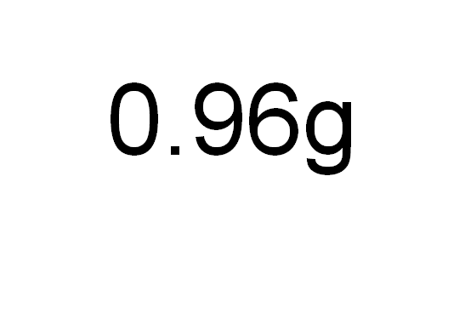
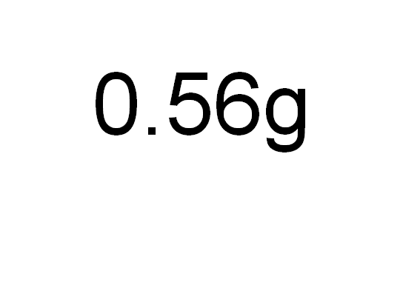

- Match each fruit and vegetable to the card showing its fibre content.

Guess the fibre content
Answers
Fruit or vegetable portion  (approx. 80g) | Fibre content per 80g
5cm of raw cucumber (skin and flesh) | 0.56g
1 medium sized apple (skin and flesh) | 0.96g
7 cherry tomatoes | 1.04g
4 heaped 15ml spoons of lettuce | 1.2g
4 heaped 15ml spoons of steamed Pak choi | 1.6g
1 medium sized pear (skin and flesh) | 2.16g
3 heaped 15ml spoons of sweetcorn | 2.48g
7 strawberries | 3.04g
2 spears of steamed broccoli | 3.04g
4 heaped 15ml spoons of green beans | 3.28g
3 heaped 15ml spoons of baked beans | 3.92g
3 heaped 15ml spoons peas (frozen and microwaved) | 4.48g

