Breakfast relay race

Breakfast relay race – Teachers’ notes (secondary)
In this activity, two groups of pupils compete against each other. Each team member is given a food card, which collectively make up a breakfast. One by one, each team member runs to a poster of the Eatwell Guide and puts their food card on the relevant section. Each team member must tag the next person before that person can start running. The name of the team that finishes first, and puts all of their food cards in the correct places on the model, is put on a leader board. The team which finishes the activity in the quickest time overall is announced at the celebration assembly and given a prize, e.g. a cereal bowl.
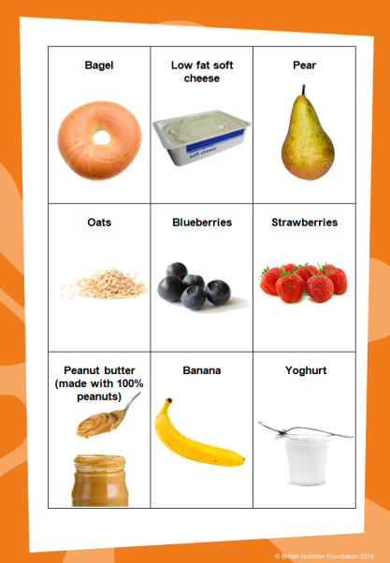
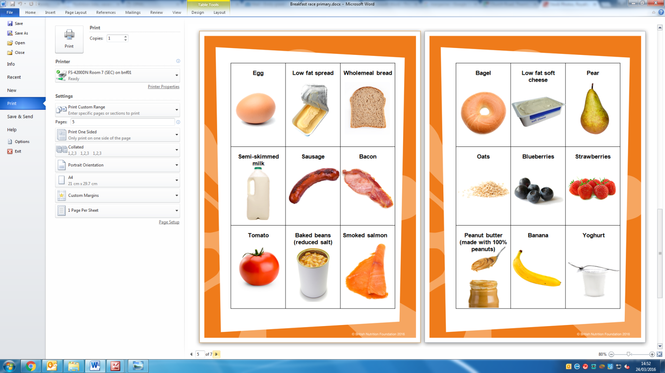
Equipment:
- blank A1 poster of the Eatwell Guide, downloadable from: http://www.foodafactoflife.org.uk/Sheet.aspx?siteId=20&sectionId=114&contentId=810);
- downloadable food cards;
- scissors;
- laminator (if you wish to laminate the cards);
- stopwatch/timer;
- multi-purpose tack;
- tape or chalk;
- pen or pencil.

Instructions
- Cut out the food cards.
- Put a piece of multi-purpose tack on the back of each card.
- Stick the blank poster of the Eatwell Guide on a wall.
- From the poster, walk the length you want the relay race to be and mark the floor with a piece of tape or chalk. This is where the children will begin the race.
- Split the pupils into two groups of four and ask them to name their group with a breakfast themed name.
- Give each group the food cards that make up one of the breakfasts in this pack.
- Tell each group what breakfast they will be sorting into the Eatwell Guide food groups.
- Each member of the group should have one food card.
- Ask the groups to stand in a line behind the tape or chalk mark.
- When you say ‘go’ and start the stopwatch/timer, the pupil at the start of each line must run to the poster of the Eatwell Guide and attach their food card to the relevant food group.
- The pupils must run back to their group’s line and tag the next member who will then run to the poster to attach their card.
- Once all the members of a group have stuck their card to the guide and are in a line behind the piece of tape or chalk mark, stop the stopwatch/timer.
- Check each group has attached their cards to the correct food groups.
- Write the winning group’s name and the time they completed the activity in on the leader board.
- At the celebration assembly, reveal the group who completed the activity in the quickest time and award each group member with a certificate and a breakfast themed prize, e.g. a cereal bowl.

Breakfast relay race

Rules
- In your group, stand in a line behind the piece of tape or chalk mark and you will be given a food card.

- Think about where on the Eatwell Guide the food should be placed.

- When your teacher says ‘Go’, the person at the front will run to the poster of the Eatwell Guide and stick the food card to the group where it belongs.

- They will run back to your group and tag the next person who will then run to attach their card.

- Once you have put your food card on the poster, stand behind the piece of tape or chalk mark.

- The group who attaches all their cards to the right group on the Eatwell Guide and in a line behind the tape or chalk mark, is the winner.

- The winning group name will be put on the leader board and they may win a prize at the celebration assembly.

Breakfasts

Breakfast 1 - Scrambled egg on toast:
- egg (Beans, pulses, fish, eggs meat and other proteins);
- low fat spread (Oils and spreads);
- wholemeal bread (Potatoes, bread, rice, pasta and other starchy carbohydrates);
- semi-skimmed milk (Dairy and alternatives).

Breakfast 2 – Cooked breakfast:
- wholemeal bread (Potatoes, bread, rice, pasta and other starchy carbohydrates);
- bacon (Beans, pulses, fish, eggs meat and other proteins);
- tomato (Fruit and vegetables);
- baked beans (Beans, pulses, fish, eggs meat and other proteins).

Breakfast 3 – Smoked salmon bagel with fruit:
- smoked salmon (Beans, pulses, fish, eggs meat and other proteins);
- bagel (Potatoes, bread, rice, pasta and other starchy carbohydrates);
- low fat soft cheese (Dairy and alternatives);
- pear (Fruit and vegetables).

Breakfast 4 – Porridge with fruit:
- oats (Potatoes, bread, rice, pasta and other starchy carbohydrates);
- semi-skimmed milk (Dairy and alternatives);
- blueberries (Fruit and vegetables);
- strawberries (Fruit and vegetables).

Breakfast 5 – Honey on toast with fruit, yogurt:
- wholemeal bread (Potatoes, bread, rice, pasta and other starchy carbohydrates);
- honey (foods high in fat salt and sugar);
- banana (Fruit and vegetables);
- yogurt (Dairy and alternatives);

Breakfast 6 – Cereal with fruit:
- cornflakes (Potatoes, bread, rice, pasta and other starchy carbohydrates);
- semi-skimmed milk (Dairy and alternatives);
- orange (Fruit and vegetables);
- apple (Fruit and vegetables).

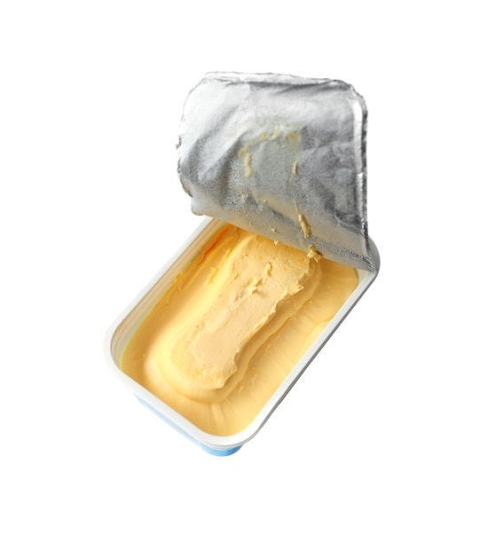    Egg | Low fat spread | 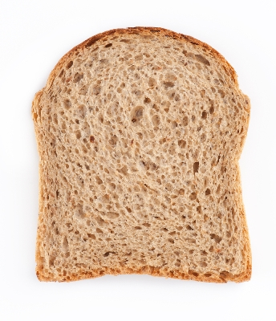  Wholemeal bread
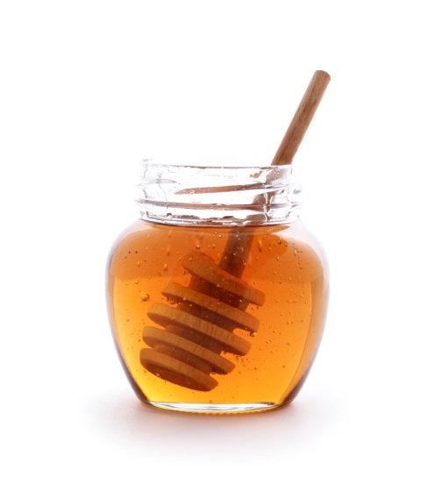  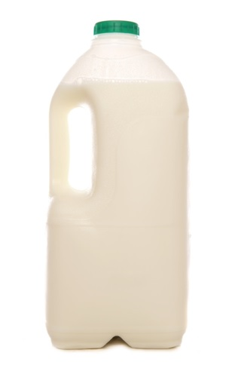  Semi-skimmed milk | 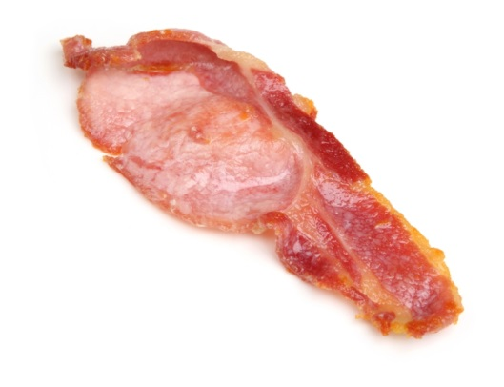  Honey | Bacon
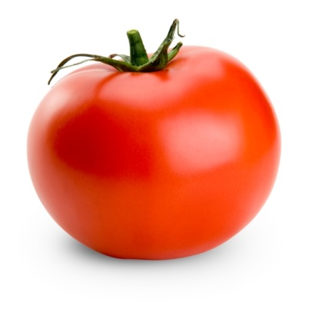  Tomato | 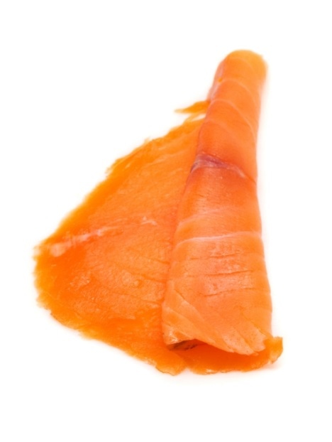  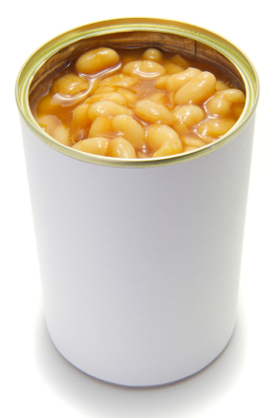  Baked beans (reduced salt) | Smoked salmon

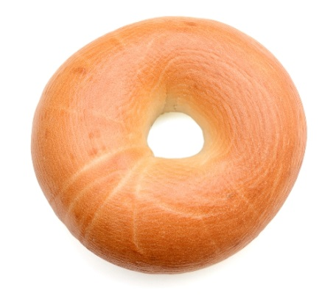  Bagel | 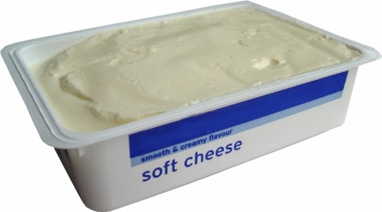  Low fat soft cheese | 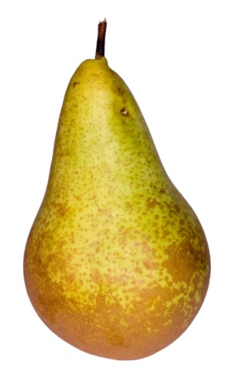  Pear
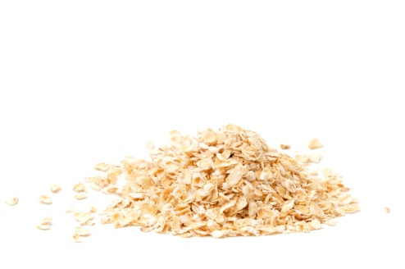  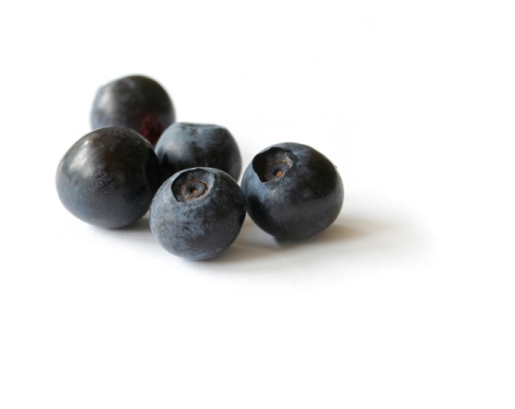  Oats | Blueberries | 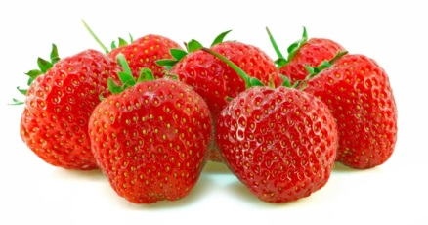  Strawberries
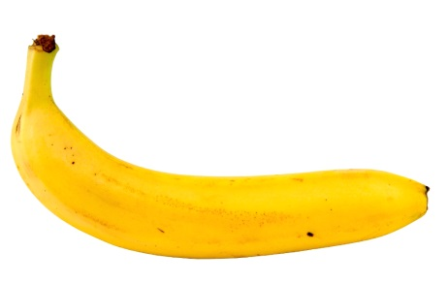  Banana | 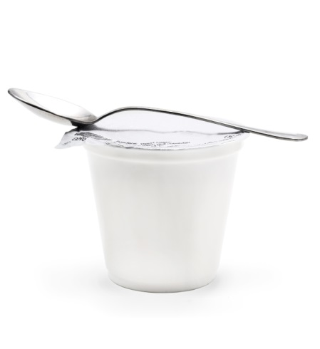  Yogurt

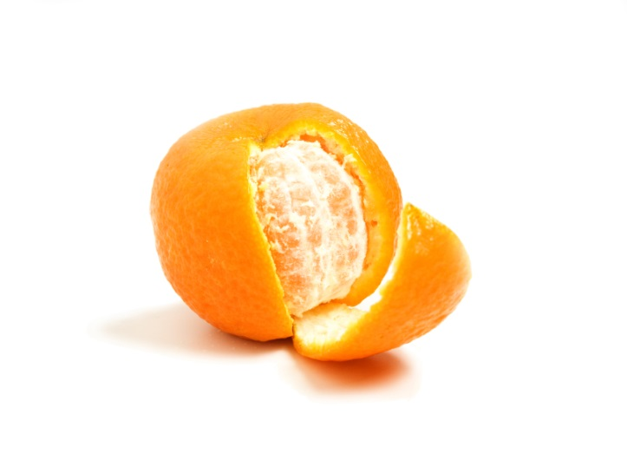  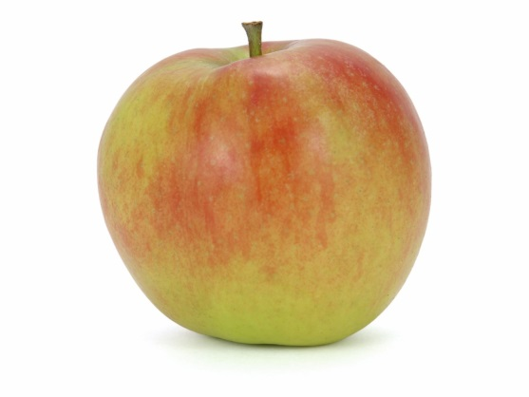  Apple | 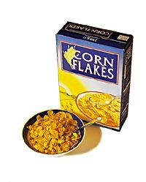  Orange | Cornflakes
Semi-skimmed milk | Semi-skimmed milk | Wholemeal bread

