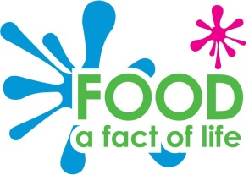
Breakfast survey

Draw a different breakfast in each circle.
Show 8 friends the four breakfasts and colour in a sunshine point on the breakfasts they have tried.

Which of these breakfasts has been eaten the most?
___________________________________________________________________________

