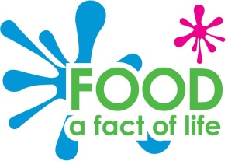
Breakfast tally chart
Number of people: ___________
- How often do you have breakfast?
Every day | Sometimes | Never

  - Do you have a drink at breakfast time?
Every day | Sometimes | Never

- What do you have for breakfast most often? (Pick one answer.)
Breakfast cereals
Porridge
Toast
Egg on toast
Bacon sandwich
Traditional English breakfast
Fruit
Yogurt
Cereal bar
Something else: _________________
Nothing

Breakfast tally chart findings

Use the information you have collected on your tally chart to answer these questions.
How many people took part in the survey?
How many people had breakfast every day?
How many people had a drink at breakfast time every day?
Complete this graph to show which breakfast is eaten most often.
10+
10
9
8
7
6
5
4
3
2
1
0
 | Breakfast cereals | Porridge | Toast | Egg on toast | Bacon sandwich | Traditional breakfast | Fruit | Yogurt | Cereal bar | Nothing
Name any breakfasts people said they had most often which were not on the list:
___________________________________________________________________
___________________________________________________________________

