Breakfast activity ideas - primary
Introduction

Don’t skip breakfast is one of the Department for Health eight tips for healthy eating.
Breakfast is an important meal because:
- it provides us with energy so we can work and be active;
- it is a great way to get some of our 5 A DAY, as well as other important nutrients;
- some studies suggest that having a healthy breakfast can help to improve cognitive function and academic performance.
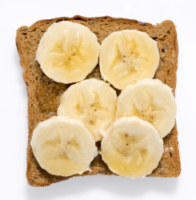
Top tips
- Make time for breakfast – just waking up 10 minutes earlier so you have time for something to eat and drink can make a big difference to your day.
- Go for variety – try different types of bread such as bagels, fruit loaf, hot cross buns, crumpets or English muffins.
- Have a drink – go for water, lower fat milk, fruit juice/ fruit smoothies to keep you well hydrated.
- Have some fruit – start your 5 A DAY with some fruit on cereal, fruit juice or a mashed banana on toast.
- Choose wholegrain varieties - wholegrain cereals and bread provide fibre which helps maintain a healthy digestive system.
- Include some calcium – milk and dairy foods are sources of calcium which is needed for strong bones and teeth.
- Include some protein – try baked beans or lean grilled bacon. Protein helps support growth and repair of muscles.
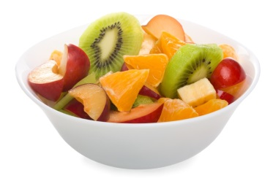
- Cut down on foods and drinks high in fat, sugar and/or salt – only have foods such as pastries, pancakes and croissants occasionally.
- On the go? Choose something quick and easy to take with you such as sandwich made the night before and a piece of fruit.

Classroom activities
Introduce the theme of breakfast to pupils using the Breakfast PowerPoint presentation.
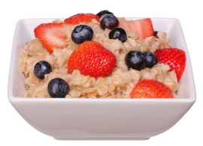
Help your pupils learn more about breakfast and its importance by trying some of these activities and resources.
- Discuss breakfast:
-What do you usually have for breakfast?
-Do you have a different breakfast at the weekend or on special occasions?
-What is your favourite breakfast?
Use the Breakfast images to aid the discussion. These could also be used to help create a breakfast display. Breakfast image labels are also available to accompany the images.
- Carry out research to find out what friends (or family) enjoy eating for breakfast. You could use these survey templates to help:
-Breakfast survey (5-7 years);
-Breakfast tally chart (8-11 years).
Older children can design their own data collection methods and results tables. Ask them to present their findings to the class.
- Undertake some breakfast research at home using the Breakfast homework sheet.
- Investigate the reasons why some people might skip breakfast using the Breakfast discussion cards.
- Carry out internet based research to find out about traditional breakfasts eaten in different countries. Present this information in a factsheet, booklet or poster.
- Research breakfast options in restaurants and cafés. Plan a breakfast menu for ‘your restaurant’ using the Breakfast menu sheet.
- Find breakfast recipes. Why not make some of them? Organise a tasting session!
- Plan and make a class breakfast at school. Why not open a class ‘breakfast bar’ one morning during BNF Healthy Eating Week?
- Design a poster or flyer to promote breakfast, include:
-the benefits of breakfast;
-the variety of breakfast options available;
-the importance of including a drink;
-tips to help people who sometimes skip breakfast.

Note: resources in bold are available on the Food – a fact of life website www.foodafactoflife.org.uk

