
Juicing station
Juicing station – Teachers’ notes
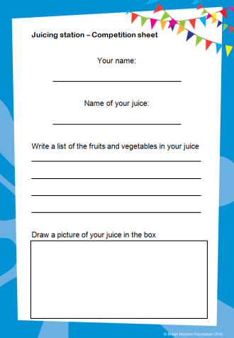
Pupils choose ingredients to create their own juice. The ‘stall’ provides a selection of fruit and vegetables for children to choose and an adult uses a juicer to create the drink. The pupils name their juice and write the ingredients on a competition sheet. The pupil who comes up with the best juice name and flavour can be presented with a BNF Healthy Eating Week certificate during an assembly.
Equipment:
- juicer;
- selection of fruits and vegetables, e.g. pears, carrot, cucumber, apples, grapes, spinach;
- equipment to prepare the selection of fruits and vegetables, e.g. chopping board, vegetable knife;
- bowls to hold the selection of fruits and vegetables;
- disposable cups;
- competition sheet (provided in this pack);
- pens or pencils.

Instructions
- Prior to the activity, purchase a section of fruits and vegetables for the children to make their juice.
- Set up the activity with the juicer and put the fruit and vegetables in bowls on the table.
- To start the activity, ask children to choose a selection of fruit and vegetable to make their juice (you may wish to limit the number they can choose).
- Prepare an appropriate amount of the child’s selection of fruit and vegetables and place in the juicer.
- Follow the instructions provided with your juicer to make the juice.
- Pour the juice into a disposable cup and give it to the child.
- Ask them to taste their juice and complete the competition form. (Retain the competition forms.)
- Repeat the activity with other children.
- After the activity, review the competition forms and choose a winner to announce during an assembly. Award the winner with a BNF Healthy Eating Week certificate.

Note: check for allergies to any of the ingredients before you allow the children to create their juice. Be aware of cross-contamination if you are using the same juicer to make all the juices.
Remember,
fruit juice and smoothies should be limited to a total of 150ml a day!

Juicing station

Rules
- From the fruit and vegetables on the table, choose the ones you would like to use to make your own juice.

- Your teacher will make your juice.

- Taste your juice and give it a name.

- Fill in the competition sheet.

- The best juice wins a prize!
Juicing station

Competition sheet

Your name:

_______________________________

Name of your juice:

_______________________________

Write a list of the fruits and/or vegetables in your juice.

_________________________________________

_________________________________________

_________________________________________

Draw a picture of your juice.

