

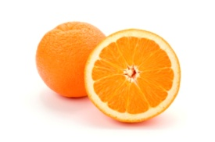

Healthy Eating pledge
My Healthy Eating Week pledge is:

I will achieve my pledge by:

To be answered on Friday – Did you meet your pledge? Explain what you did.

