How healthy are you?
Complete the following quiz to find out how healthy you are!

Circle your answers and add up the scores using the key on the results sheet.
1. What do you base your meals on?
a) Potatoes, bread, rice, pasta and other starchy carbohydrates
b) Beans, pulses, fish, eggs, meat and other proteins
c) Dairy and alternatives
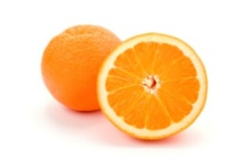
2. How many portions of fruit and vegetables do you have each day?
a) Less than 2
b) 2 – 4
c) 5 or more

3. How many portions of oily fish do you eat each week (e.g. salmon, mackerel, trout,
fresh tuna, herring, sardines)?
a) None
b) 1 portion
c) 2 or more portions

4. How often do you have high fat and/or high sugar foods (e.g. chocolate, biscuits, crisps,
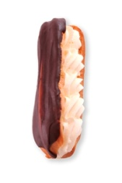
butter, pastries, sausages, cream, pies, cakes, fizzy drinks)?
a) Once a week
b) Once a day
c) A couple of times every day

5. How often do you add salt to your food, either when cooking or before eating?
a) Never
b) Sometimes
c) Most of the time

6. How many days a week do you take part in moderate to vigorous intensity
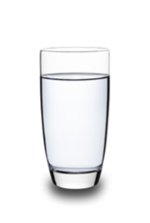
activity for at least 60 minutes?
a) Everyday
b) 3 – 6

c) Less than 3

7. How many drinks do you have each day?
a) Less than 3
b) 3 – 5
c) 6 – 8+

8. Which of the following are you most likely to drink?
a) Water

b) Soft drinks (not diet drinks)
c) No added sugar squash or milk

9. How often do you eat breakfast?
a) Everyday

b) Most days
c) Never

