Healthy Eating Week Tutor Time Activities
Meal occasions – breakfast, lunch and dinner
Activity one
Use the Breakfast tally chart to carry out a class breakfast survey. Tally who has breakfast every day, who had a drink at breakfast every day and which breakfast options are the most popular in your class. Discuss reasons why people may not eat breakfast.
Activity two
Using the Eatwell Guide as reference, use the Come eat with me worksheet to get pupils to create their most impressive three course school lunch. Pupils can share their ideas with the class and explain why they have chosen those foods for their menu. You could have a class vote to decide which one is the winning menu. To extend the activity, print off and cut out the Difficult diners cards so there is enough for one each for every pupil. Ask each pupil to choose a card at random. The pupil should then adapt their lunch menu so it is suitable for the diner on their card.
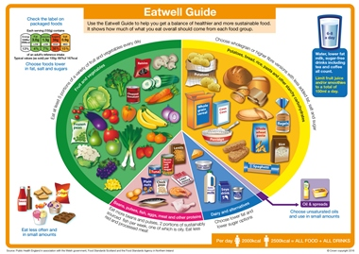
For more information about the Eatwell Guide, go to www.foodafactoflife.org.uk

Activity three
Why not discuss the Meal occasions discussion topic with your tutor group? A discussion PowerPoint slide and some stimulus questions are provided.

