Healthy Eating Week Tutor Time Activities
General Activities
Activity one
Print off the Healthy Eating Week pledge worksheet. Ask each member of the class to write a health pledge on the Healthy Eating Week pledge worksheet, based on the eight tips for healthy eating, which they will aim to achieve over Healthy Eating Week. A health pledge is a statement of a positive change that someone promises to make about their health. Throughout the week discuss with the class how they are doing with their pledges. At the end of the week, pupils can complete the worksheet, stating whether they met their pledge or not. Why not use these health pledges to create a class display?
The eight tips for healthy eating are:
- Base your meals on starchy foods
- Eat lots of fruit and veg
- Eat more fish – including a portion of oily fish
- Cut down on saturated fat and sugar
- Eat less salt
- Get active and be a healthy weight
- Don’t get thirsty
- Don’t skip breakfast
Example health pledges are below:
Health pledge | How I will achieve my pledge
I will eat my 5 A DAY every day | I am going to swap my crisps at break time and biscuits after school for a piece of fruit or a vegetable snack to increase my fruit and vegetable intake.
I will keep active for 60 minutes a day | I am going to ride my bike to and from school instead of getting the bus.
I will get cooking | I am going to prepare myself a different healthy packed lunch every day and cook my family a nutritious dinner on at least one weekday evening.

Activity two

Print out a copy of the HEW Class Challenge trackers. Set the targets for the week with the class. Survey the class on how many glasses of fluid, minutes of activity, numbers of fruit and vegetables and whether they have had breakfast each day. You could encourage other tutor groups to carry out this activity and have an inter-tutor group competition. Pupils could also keep their own target tracker.
Class challenge trackers:
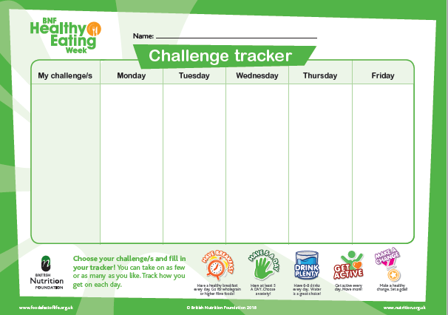
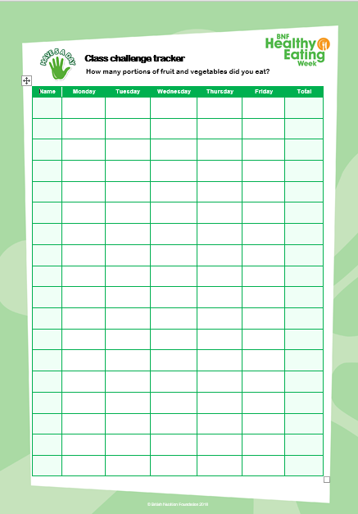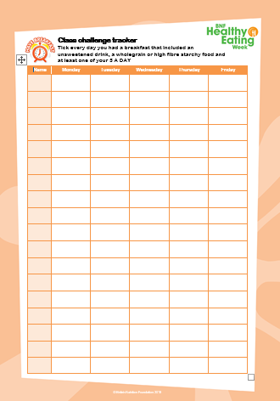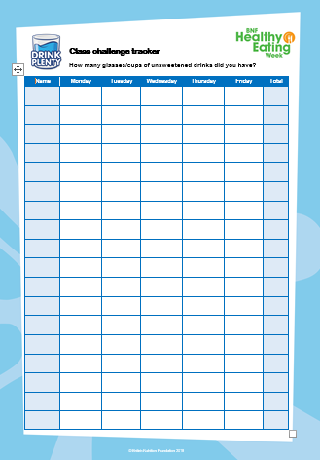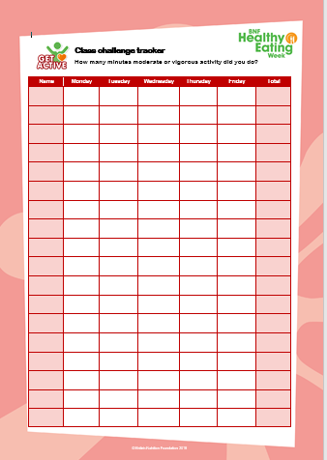
Individual challenge tracker:

Activity three

Ask pupils to write down questions about healthy eating, cooking, food provenance and physical activity they would like to have answered. Get them to swap their question with another pupil who is then responsible for finding out the correct answer. Why not combine all the questions and answers into a Healthy Eating Week Q and A document which could be published online or in a school newsletter?

