Grater – risk assessment
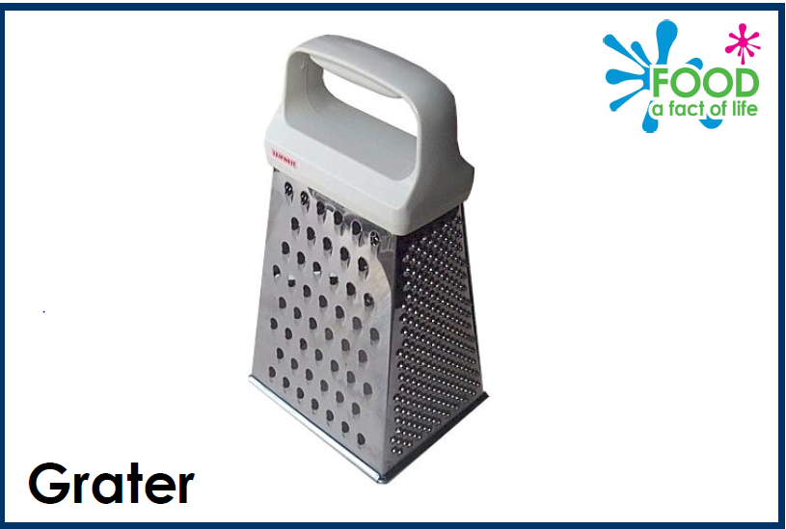

Hazards | Risk level (H, M or L) | Precautions and control measures
Injury from graters such as:

