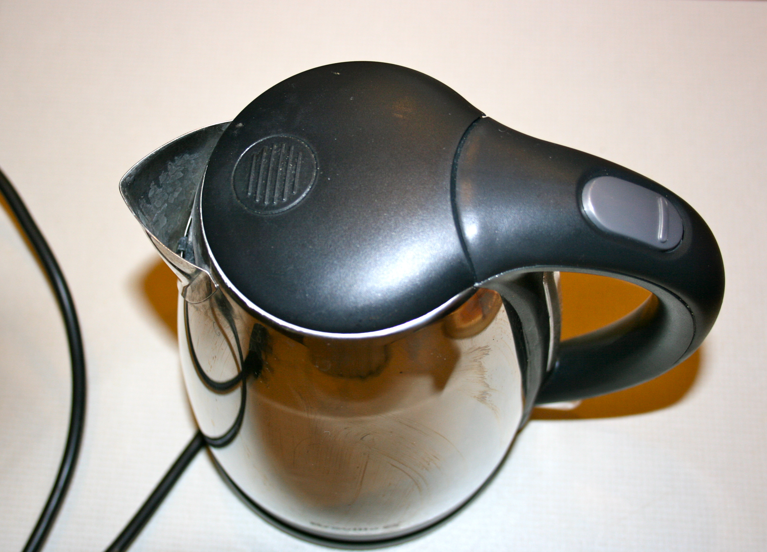
Kettle – risk assessment

Hazards | Risk level (H, M or L) | Precautions and control measures
Injury from kettles such as:

