Equipment
1. List the equipment needed to prepare and cook this dish.

Herby sausage jambalaya
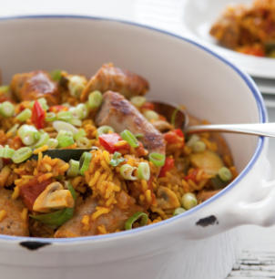
Ingredients
400g Lincolnshire sausages
1 x 5ml spoon oil
2 garlic cloves, crushed
2 x 5ml spoons mild chilli powder
2 x 5ml ground turmeric
225g easy cook brown rice
450ml pork stock
400g canned chopped tomato
Ground black pepper
3 whole cloves
5 spring onions, chopped
½ red pepper, seeded and chopped
100g button mushrooms, quartered
1 courgette, halved lengthways, sliced diagonally
Equipment

Method
1. Heat the oil in a large saucepan and cook the sausages over a medium heat until browned.
2. Remove from the pan and keep to one side. When cool enough to handle, cut each sausage in half.
3. Add the onion, garlic, chilli powder, turmeric and rice to the pan and cook until the rice is opaque.
4. Add the stock, chopped tomatoes and pepper. Bring to the boil, cover and simmer for 20 minutes.
5. Add the sausages and the remaining ingredients and continue to cook, uncovered, for a further 10 minutes or until the liquid is absorbed.
6. Sprinkle with the green tops of the spring onions before serving.

2. List the food skills used to make this dish.
Food skills

