Multi-purpose resource activities

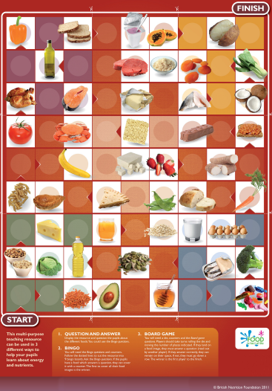

This resource is aimed at secondary pupils aged 11-14 years but could be used with other pupils as appropriate. It has been developed to support teaching and learning about energy and nutrients.

The resource can be used in 3 different ways.

1. Question and answer
The resource can be displayed in the classroom and used to support a short ‘warm-up’ or revision session about food, energy and nutrients. You could ask pupils questions about the foods on the resource, e.g. name a mineral found in apricots. Alternatively, ask questions which are answered by images on the resource, e.g. which foods on this resource would be a source of protein? You might prefer to create your own questions to suit the ability of your class or topics you have been focusing on, or you could use the Bingo questions from the activity below.

2. Bingo
You will need to download the Bingo questions and provide counters. Follow the dotted lines to cut the resource into 9 bingo boards. Cut out the Bingo questions and shuffle them (you could laminate the questions for durability). Pupils could have one board each or work in 2s or 3s, depending on the size of your class and abilities of the pupils. Each board will need 5 counters. Ask the Bingo questions. If the pupils have a food which answers the question, they can cover it with a counter. Place the questions you have asked to one side so you can check that pupils have covered the correct foods at the end of the game. The first to cover all the foods on their board is the winner.

3. Board game
You will need a die, counters and the Board game questions. This activity is suitable for 2-6 players. Players should take turns rolling the die and moving the number of places indicated. If they land on a food image, they must answer a question (read out by another player). If they answer correctly, they can remain on their space, if not they must move down a row. If a player is already on the bottom row, they must go back to the start. The winner is the first player to the finish.

