Physical activity dice

Cut and glue the dice.

Roll the dice and complete whichever activity the dice lands on.

Share the dice with friends.

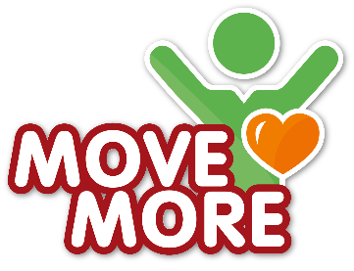
✄
Glue

Don’t forget to have a drink after you finish the game – water is a good choice!

Glue
Glue
Glue
Glue
Glue
Glue
✄
Jump as high as you can, 5 times
Do 5 pull-ups
Move as quickly as you can from one side of the room/playground to the other.
Move across the room/playground weaving between obstacles.
Bounce a ball against a wall and catch it, 5 times.
Run in a circle for 10 seconds.

