Star jump challenge
Teachers’ notes

In this activity, children complete as many start jumps as they can in one minute. There is a scoreboard and the child who does the most start jumps wins and can be presented with a BNF Healthy Eating Week certificate during an assembly.

Equipment:
• Stopwatch or timer.
• Scoreboard (provided in this pack).
• Tape or chalk.
• Pen or pencil.

Instructions
1. Mark the spot where the children will jump with a piece of tape or chalk.
2. To start the activity, ask a child to stand on the spot and explain the object of the activity is for them to do as many star jumps as they can in one minute.
3. Once the child is ready, start the stopwatch or timer and say ‘Go’.
4. Count the amount of star jumps the child completes.
5. After one minute, tell the child to stop and reveal how many star jumps they completed.
6. Write their name and the number of star jumps on the scoreboard.
7. At an assembly, reveal which child did the most start jumps and award them with a certificate.

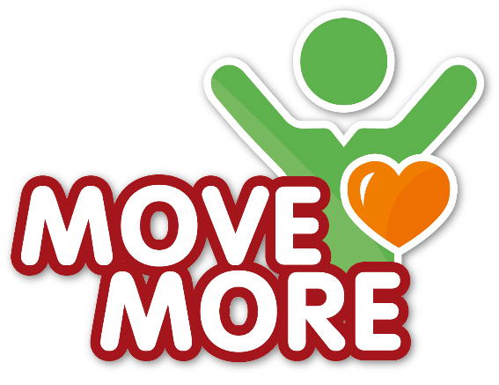

Star jump challenge
Scoreboard
Name | Number of times won |  | Name | Number of times won

