Hula-hoop challenge
Teachers’ notes
In this activity, two children compete against each other to see who can hula-hoop for the longest. The winner stays on.
The child who beats the most people is the winner!
Equipment:
- 2 x hula hoops;
- tape or chalk;
- scoreboard (provided in this pack);
- pen or pencil.

Instructions
- To set up the activity, choose two areas where the children will hula-hoop and mark these with tape or chalk.
- Make sure the two spots are far enough away so the children do not hit each other once they start hula-hooping.
- To start the activity, give each child a hula-hoop and ask them each to stand on one of the spots.
- Once they are both in position, tell the children to begin hula-hooping.
- The child who hula-hoops for the longest wins and remains on their spot.
- Write their name on the scoreboard.
- Invite another child to compete against them. Keep score of how many times they win.
- When there is a new winner, add their name to the score board and record the number of times they win.
- Repeat.
- Reward the winner with a BNF Healthy Eating Week certificate.

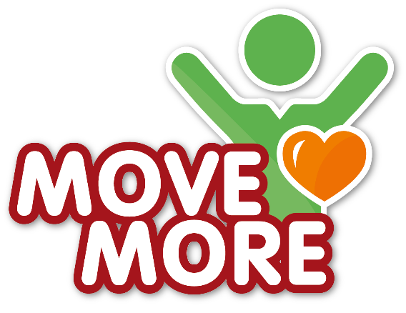
Hula hoop challenge
Scoreboard
Name | Number of times won |  | Name | Number of times won

