
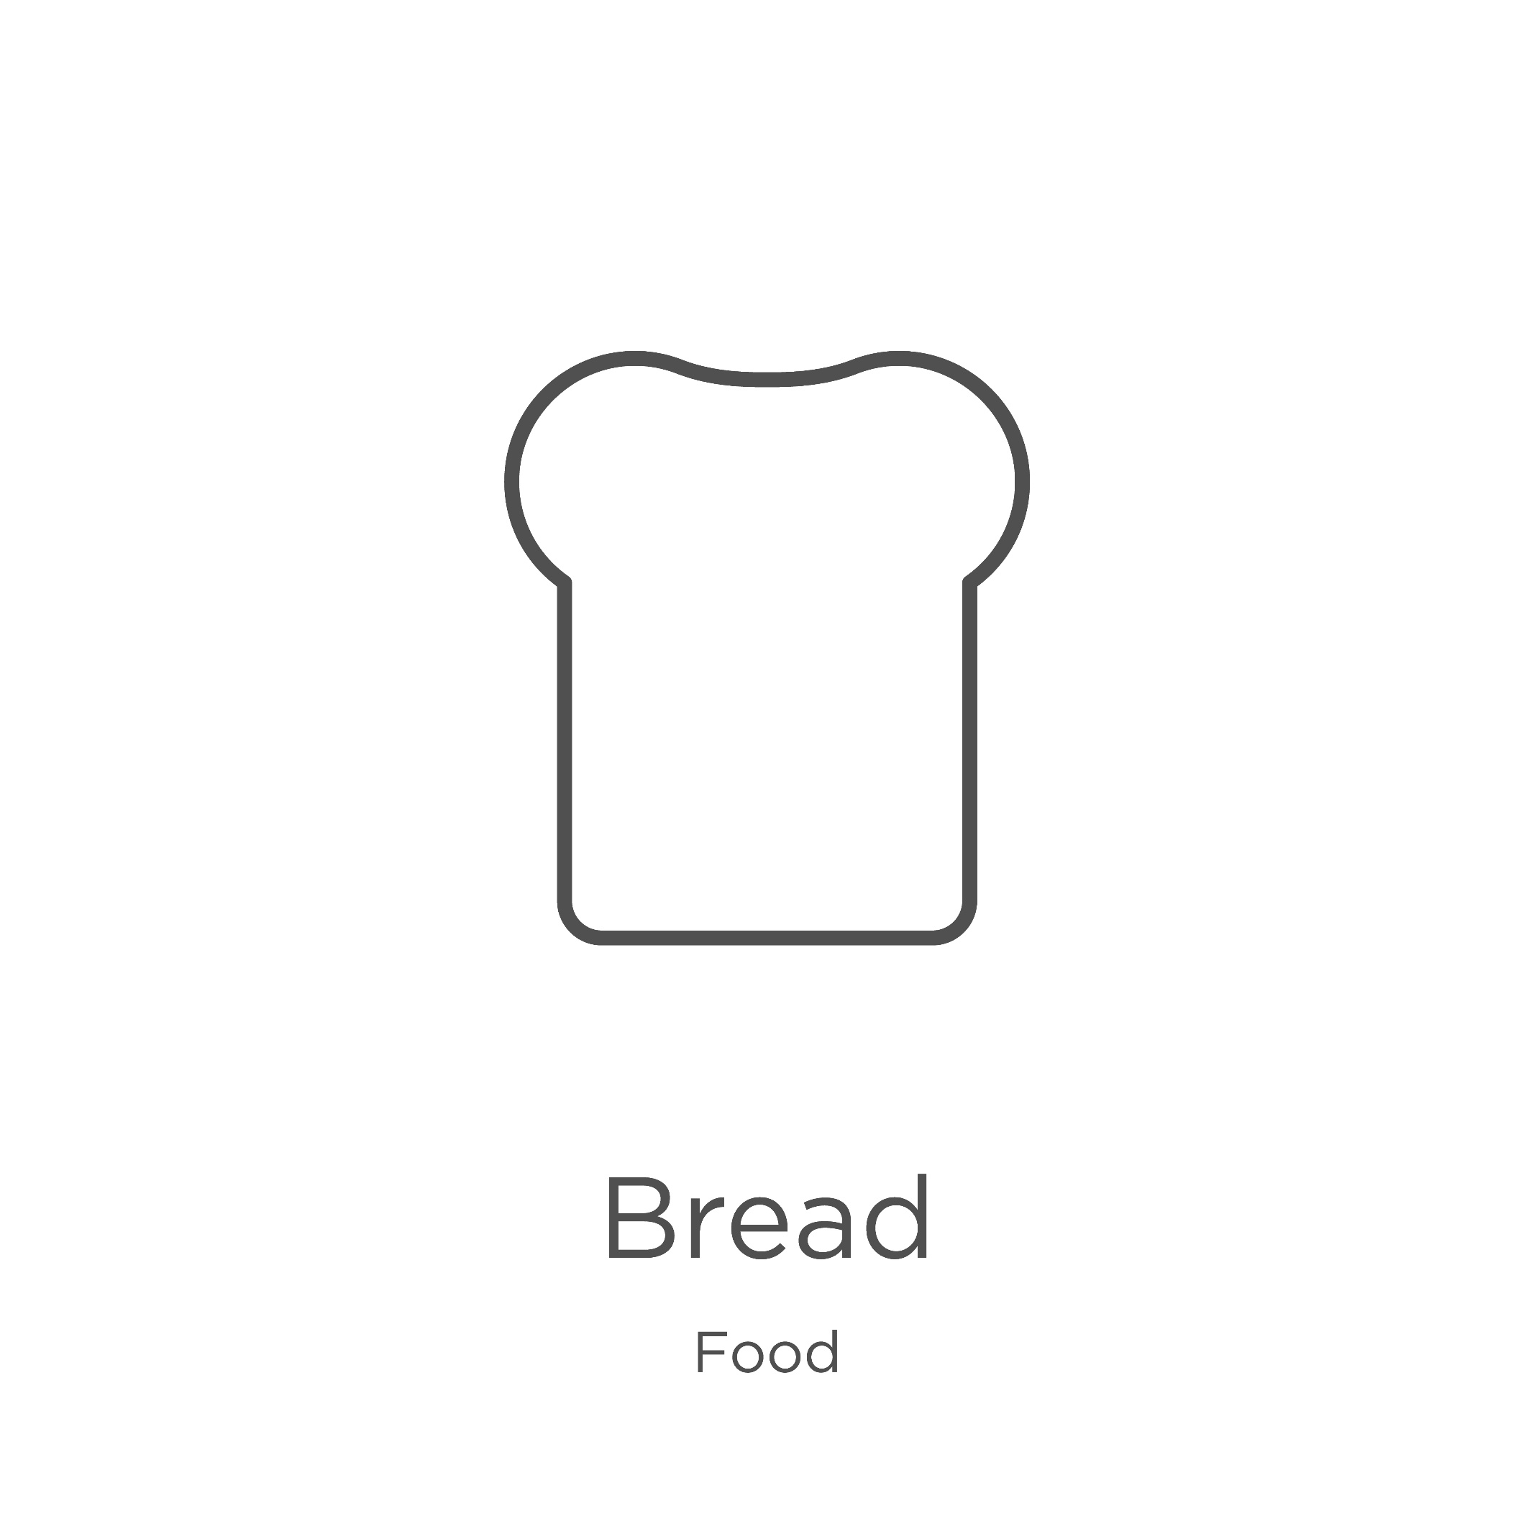
Wholegrain tracker

Colour or stick a dot on the toast for every wholegrain food eaten at nursery.

How many wholegrain foods have you eaten this week?
