Yan’s wholegrain swaps


Yan doesn’t have any wholegrains in his diet!
Yan’s diet |  | Healthy wholegrain swaps
  White bagel for breakfast | →
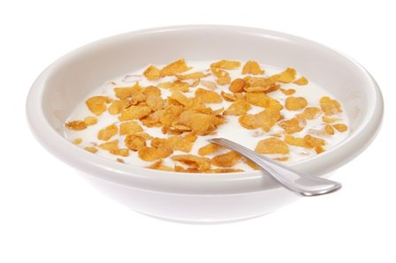  Breakfast cereal | →
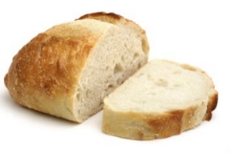  White bread for lunch | →
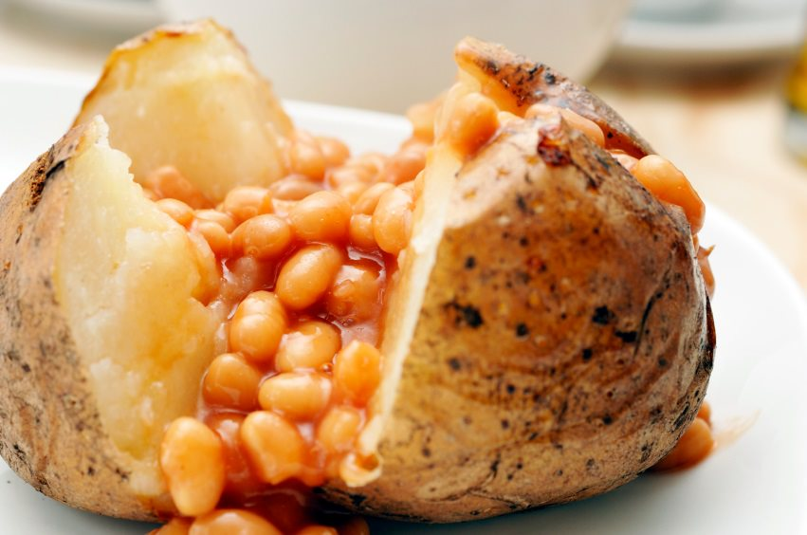  Jacket potato with beans | →
  Fish and chips for dinner | →
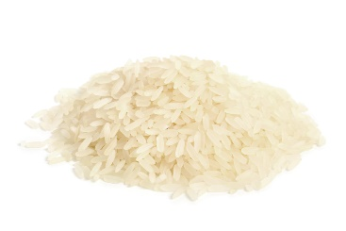  White rice for dinner | →
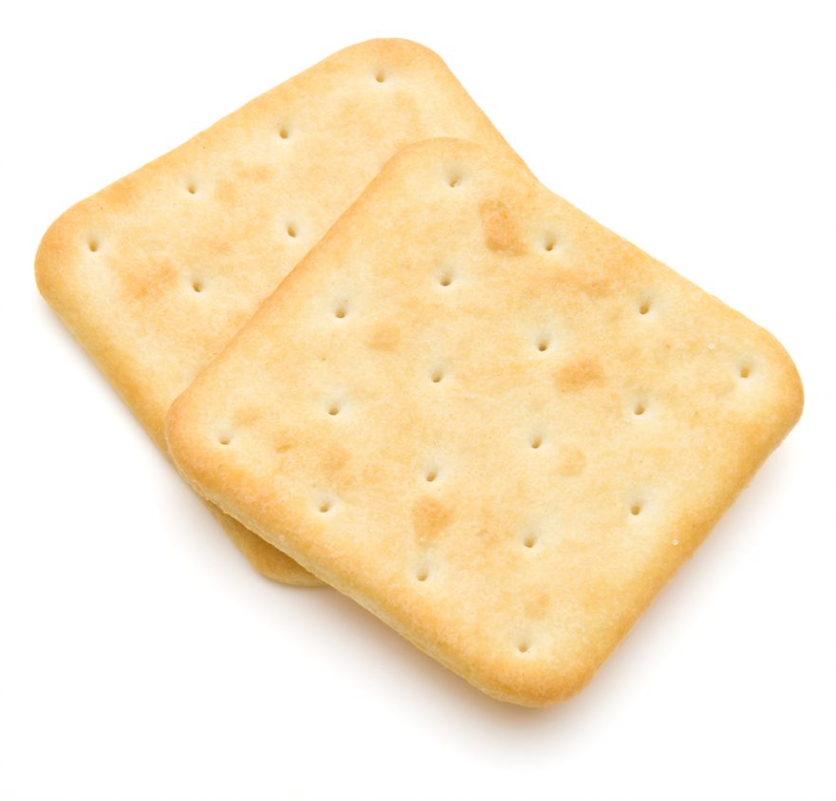  Cream crackers as a snack | →
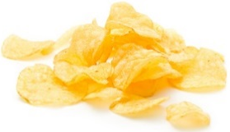  Crisps as a snack | →
Suggest TWO wholegrain swaps for each food below.

