Fantastic fibre!
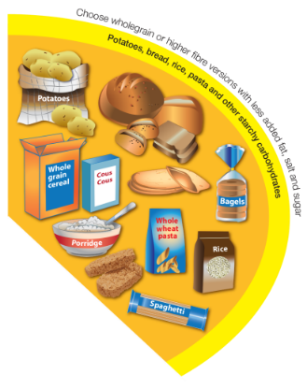

It is recommended that starchy food should make up

just over a third of the food we eat and that we should choose higher-fibre, wholegrain varieties when we can.

Wholegrain food includes: wholemeal or wholegrain breads; wholewheat pasta; brown rice; wholegrain breakfast cereals; porridge oats and grains, such as bulgur wheat, barley, spelt, freekeh or quinoa.

Complete the diet diary below and identify how you could have increased your fibre intake by adding wholegrain food.

Meal | What I ate | What changes could I make to increase my fibre intake?
Breakfast

Lunch

Evening meal

Snacks

Extension task

Explain the importance of increasing the amount of wholegrains in your diet.

(Write your answer on the back of this sheet.)

