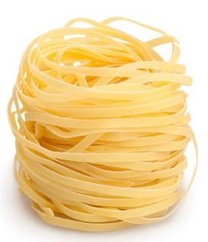
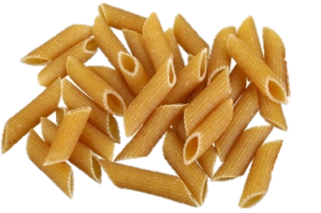
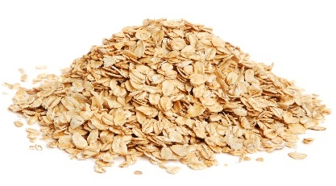
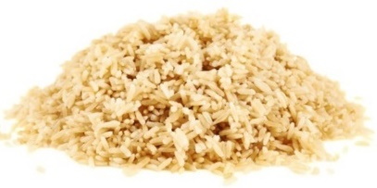
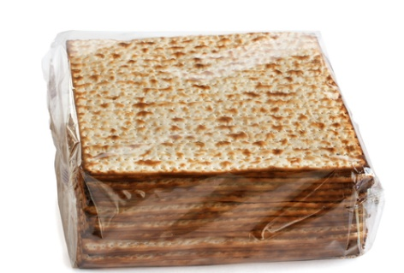
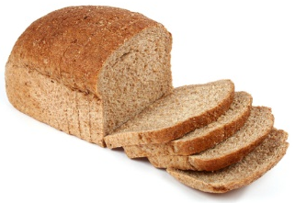
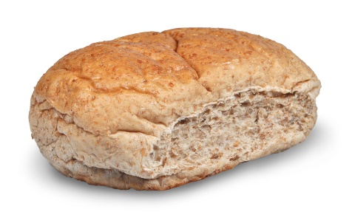
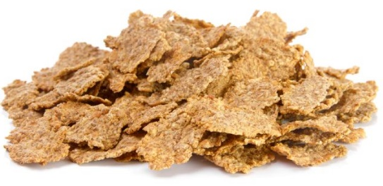
40g Bran Flakes
45g porridge oats
180g brown rice
1 large wholemeal bread roll
3 wholemeal crackers
2 slices of wholemeal bread
180g white pasta
180g wholemeal pasta
7.6g
3.1g
3.5g
2.7g
5.4g
1.4g
5.6g
5.0g

