I don’t like wholegrains…

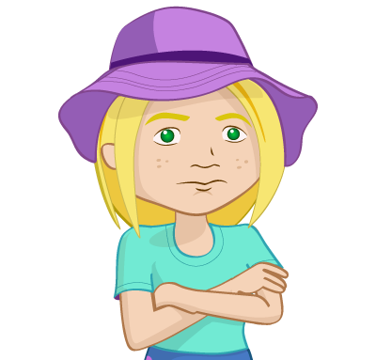
Nicola does not like the taste of wholegrains and says she does not want to eat any.
Write her a letter explaining why eating wholegrains is important and why it is beneficial for her. Include examples of wholegrains she can eat.
Dear Nicola,

______________________________________________________
______________________________________________________
______________________________________________________
______________________________________________________
______________________________________________________
______________________________________________________
______________________________________________________
______________________________________________________
_____________________________________________________
______________________________________________________
______________________________________________________
______________________________________________________
______________________________________________________
______________________________________________________
______________________________________________________

______________________________

______________________________

