

Harvest Teachers’ Guide

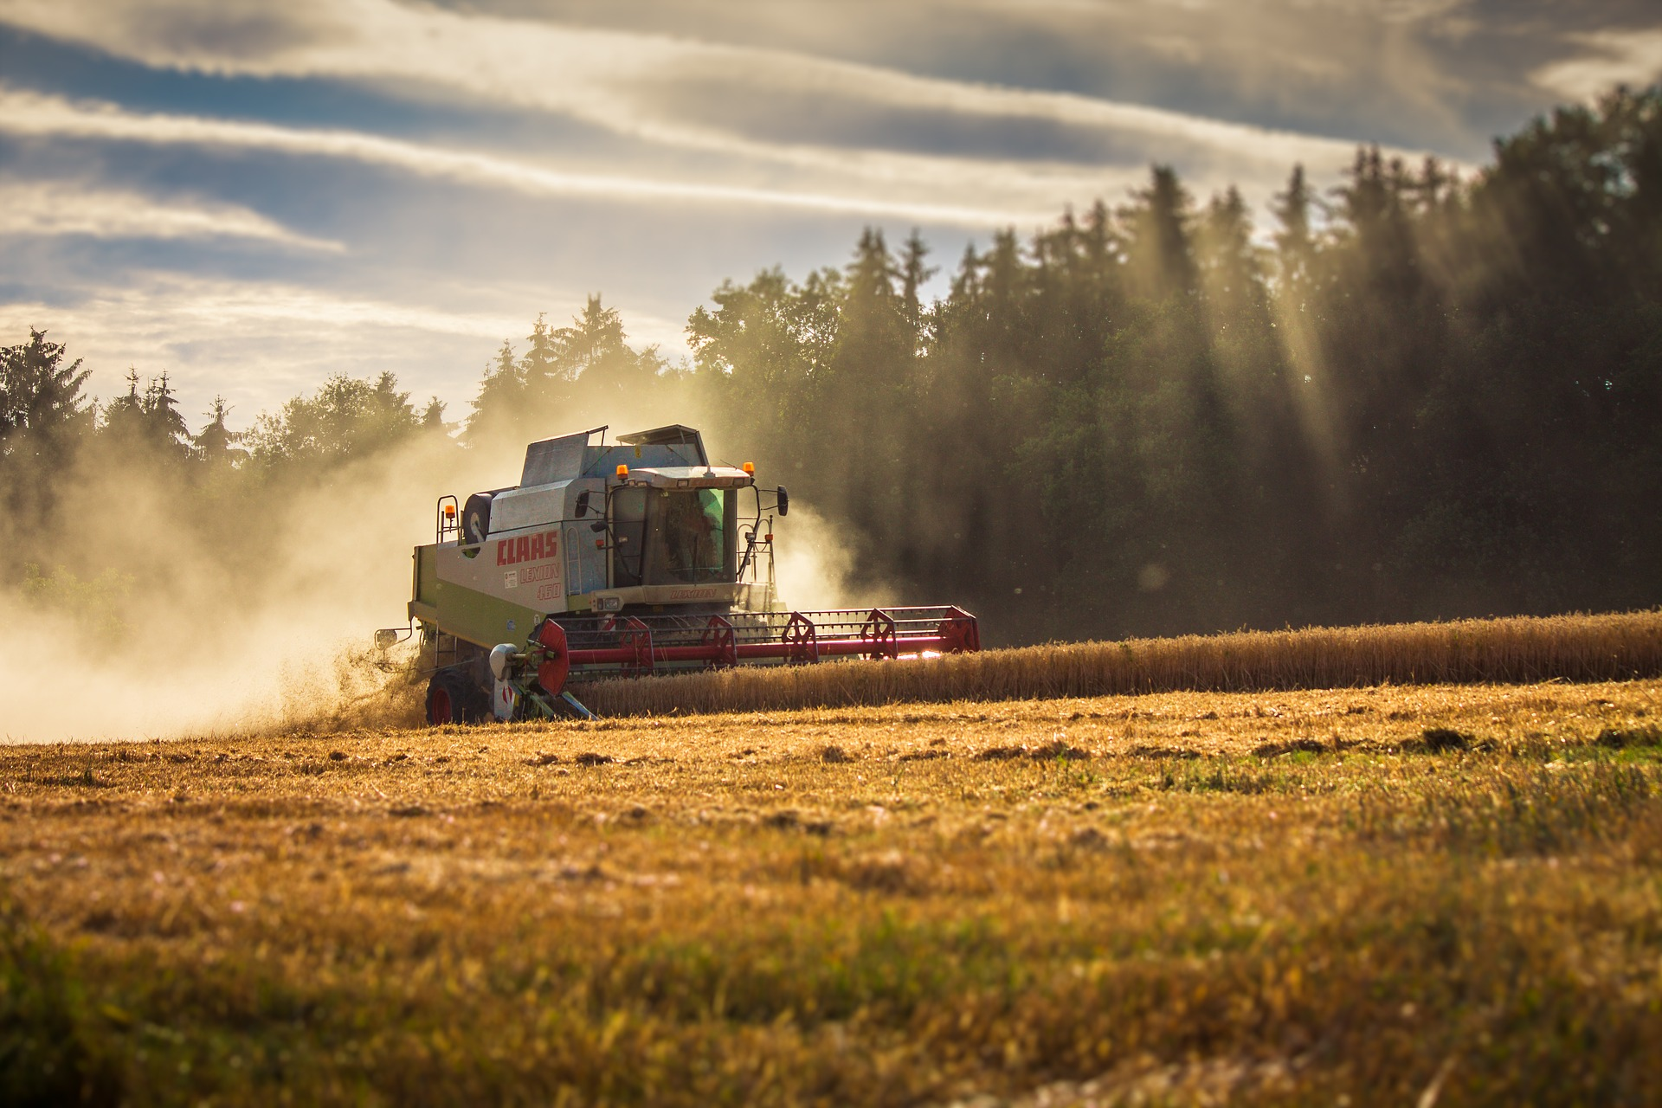

Welcome
This harvest activity pack has been designed to support the teaching and learning around the importance of where food comes from, specifically the harvesting of food. Wheat is used as the example, as ‘harvest festival’ is usually a topical theme used in many schools throughout the UK.

Pages 3-6 provide background information to the teacher.

Pages 7 to 10 gives details on the resources, with activity ideas, to bring harvest to life in the classroom.

Contents

Background information
The history of harvest festival | 3
Wheat | 4
The cereal harvest: from field to table | 5
Milling: facts and figures | 6

Classroom activities and resources
- A harvest festival assembly – a presentation | 7
- Harvest festival and the cereal harvest presentations | 7
- Quizzes – links to two online quizzes about harvest | 8
- Wheat harvest factsheet | 8
- Field to bread – sequencing cards | 8
- The power of flour poster | 8
- Practical activities, including cooking | 9
- Where does food come from? Let’s explore! | 10

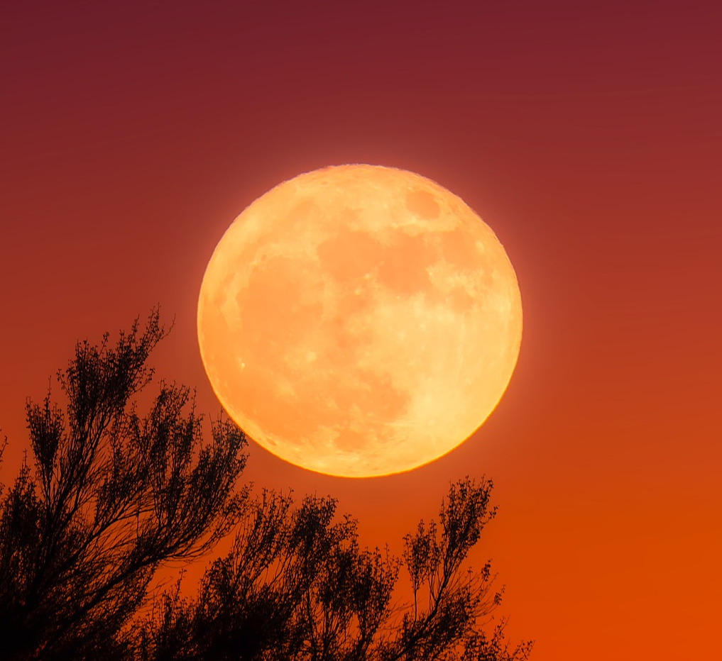
The history of Harvest Festival
Harvest Festival is traditionally celebrated in the UK on the Sunday nearest the full ‘Harvest Moon’. In the past, celebrations used to begin on 1st August, with the very first loaves of bread from the new wheat crop.

A celebratory dinner at the end of the harvest season was held on Michaelmas day (29th September). The origins of the Festival date back to Pagan times, before being adopted by the Church; in fact the word ‘harvest’ comes from the Old English word ‘haerfest’, which means autumn.

Harvest Festival has a number of traditions associated with it, including the:
- baking of ‘harvest loaves’, often these loaves have ornate designs. A common traditional design is to bake bread into the shape of a wheat sheaf;
- singing of songs about the harvest;
- making of ‘corn dollies’;
- creation of food baskets to be shared - either with each other or donated to those in need;
- arrangement of vibrant floral displays.

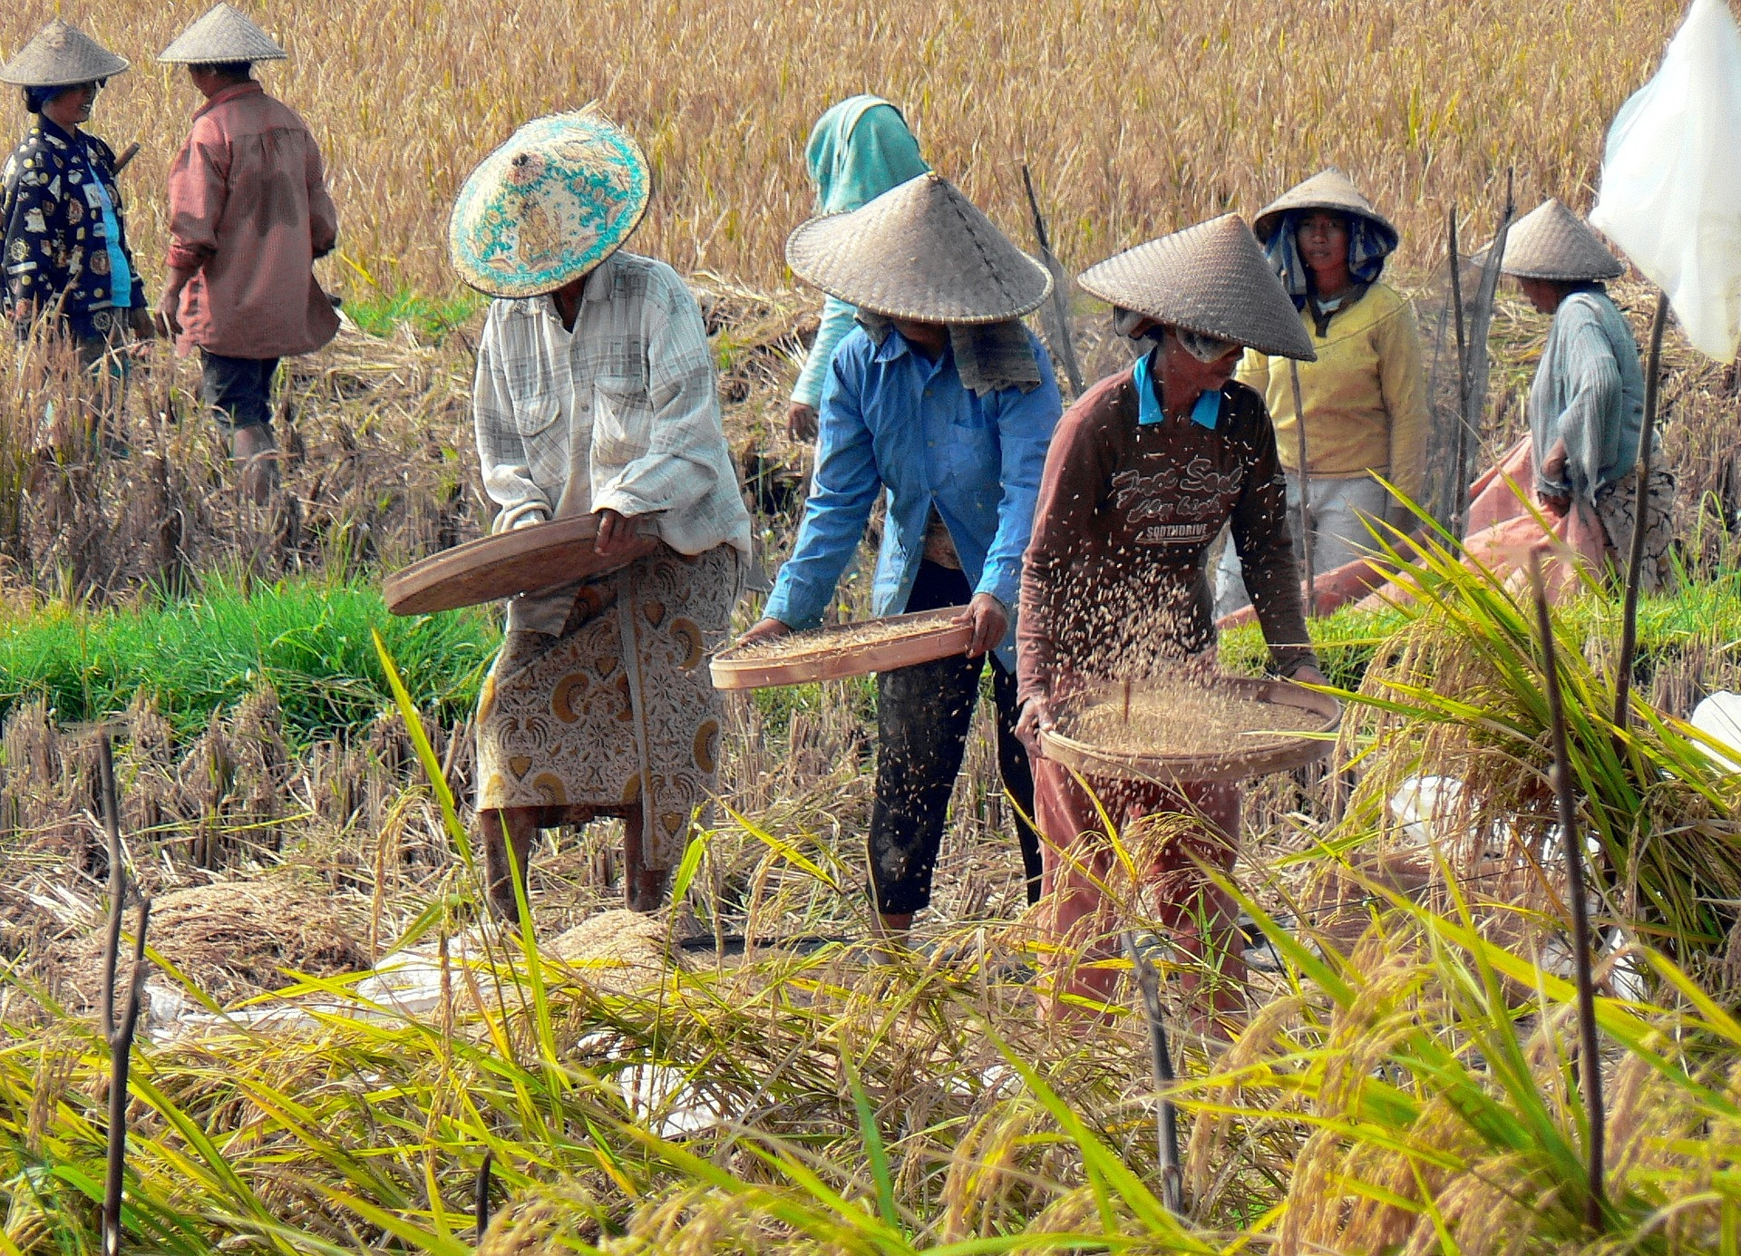
Harvest-time is celebrated around the world because of the importance of having enough food to eat for the rest of the year. Not all countries celebrate harvest in the same way, or on the same date, but many countries have their own variation on the festival.

The main cereal harvest takes place in late summer to early autumn. A combine harvester can make short work of a field of wheat. Some can process over 500 tonnes in a day! The combine harvester also ‘threshes’ the grain, to separate the seed from the stalks and inedible outer casing.

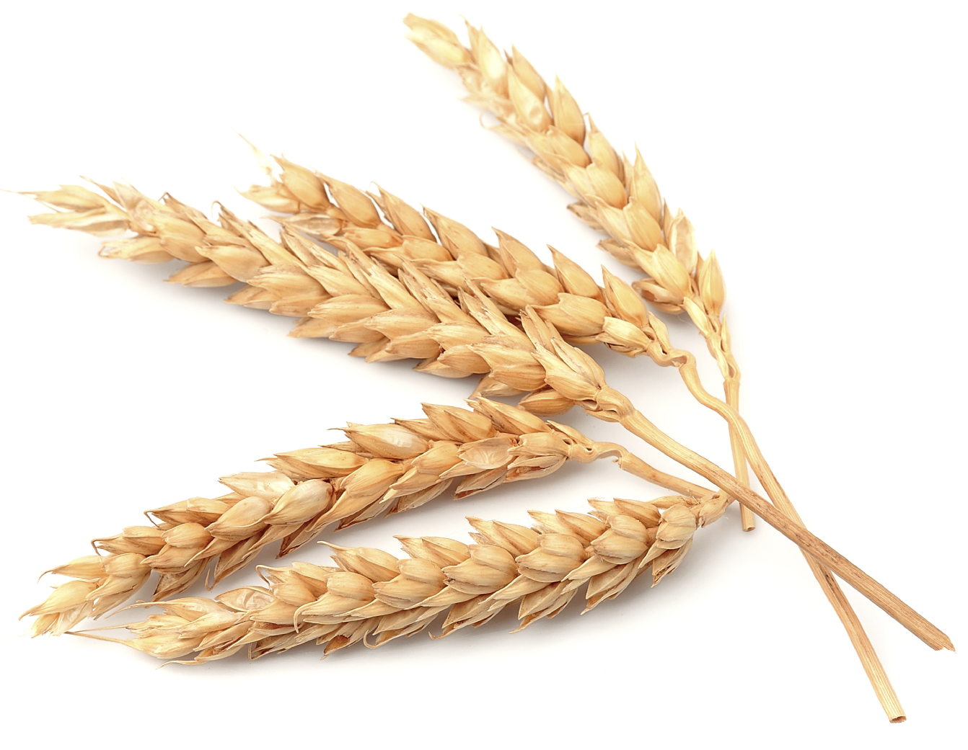
Wheat
Wheat is one of the most important cereal crops grown in the UK. Its main use is to make flour that can be used in the production of bread, breakfast cereals, pasta, cakes, biscuits and many other foods.

Here are some amazing facts about wheat:
- In the UK, the land used for wheat is around 1.9 million hectares – that’s an area nearly the size of Wales!
- 5 million tonnes of wheat is processed by UK flour mills each year.
- 85% of wheat used by UK flour mills is grown in the UK.
- There are five main species of wheat grown in the UK; each one has properties that make them suitable for different uses. For example, durum wheat is mostly used to make pasta.
- The modern ‘common wheat’ has been cross-bred from three different species, giving it desirable properties from each one.

Wheat varieties
Wheat species | Percentage of world production | Main uses
Common wheat  (Triticum aestivum) | ~95% | Bread, cakes, biscuits, breakfast cereals. Also the main variety sold for home use as flour.
Durum wheat  (Triticum durum) | ~5% | Pasta, as well as often being used for couscous and bulgur. Occasionally used in bread making.
Emmer wheat  (Triticum dicoccum)  Einkorn wheat  (Triticum monococcum)  Spelt  (Triticum spelta) | <1% | These varieties are rarely grown in the UK, but are occasionally used for variety in some products. Some are popular in other countries; for example spelt bread may be found more widely in Poland. In countries with poor soils or difficult climates, these varieties can sometimes grow better than common wheat.

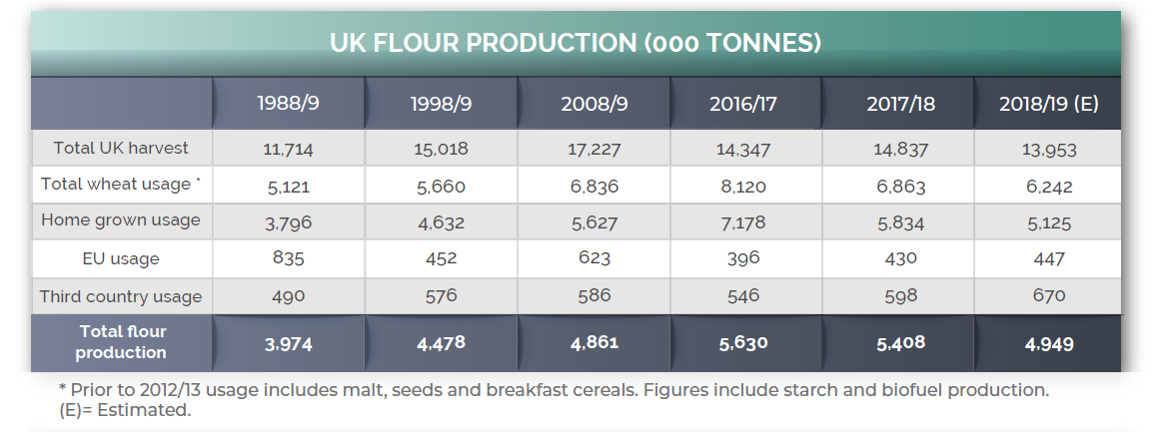
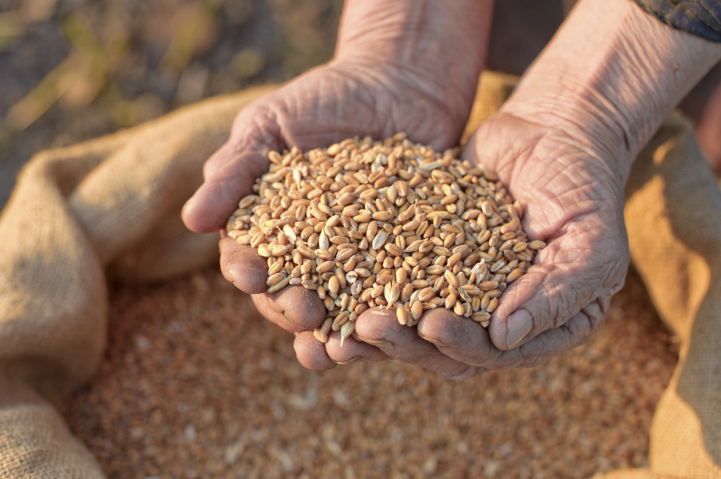
The cereal harvest: from field to table

A ‘cereal’ means any grain that is used for food. Cereals are some of the most important crops in the UK, because they can be used to make staple foods such as bread, pasta and breakfast cereals. Cereals include grains such as wheat, barley and rye. Wheat is the most commonly grown cereal crop in the UK, with between 11 and 16 million tonnes grown each year.
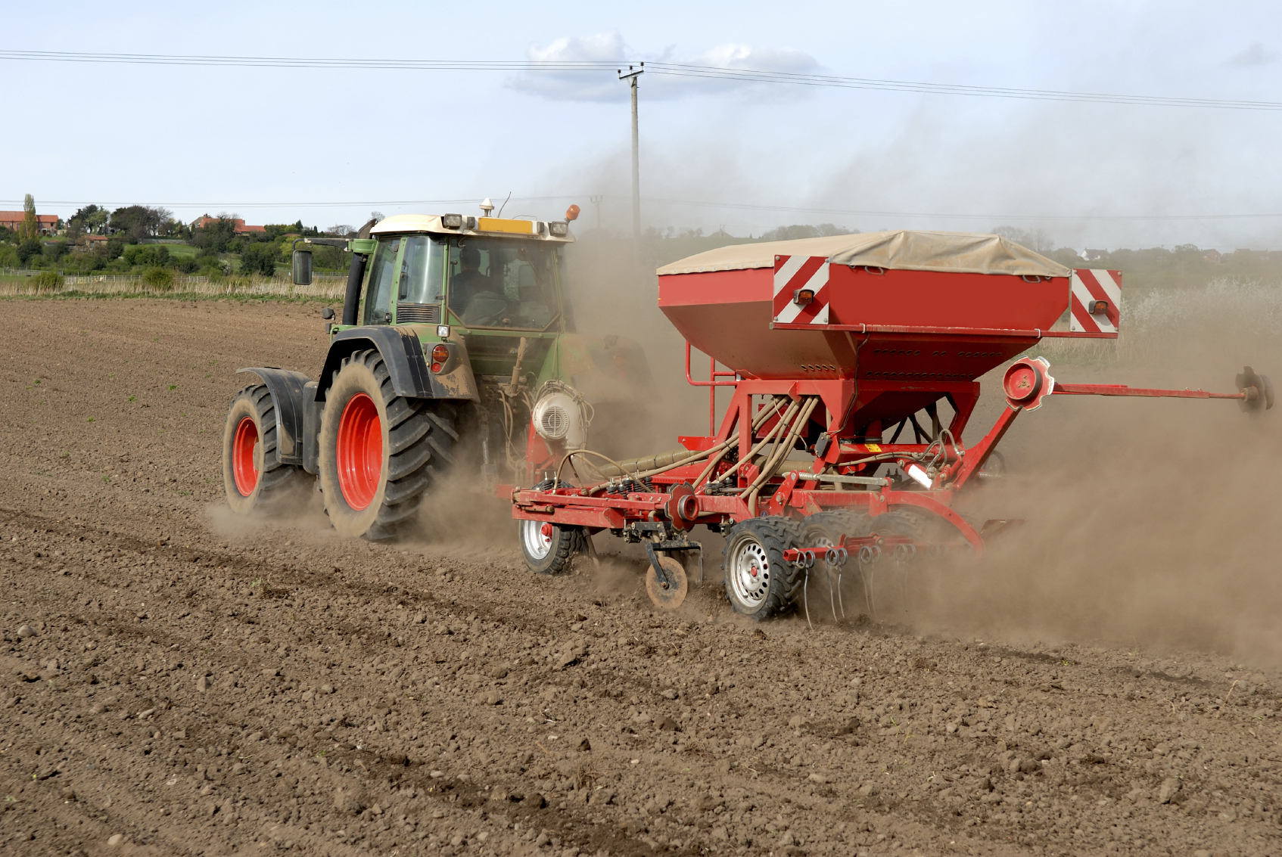
Planting
Most wheat is ‘winter wheat’ and farmers usually plant it between September and November, before being harvested in late summer or early autumn of the following year. Spring wheat grows quickly, and is planted in the spring and harvested in late summer or early autumn of the same year. Barley and rye also have winter and spring varieties.

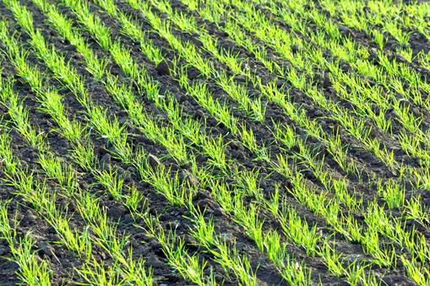
Growing
Spring wheat grows quickly, and is planted in the spring and harvested in late summer or early autumn of the same year. Barley and rye also have winter and spring varieties.

Harvesting
The main cereal harvest takes place in late summer to early autumn. The harvest used to be performed by hand with sickles and scythes, but these days machinery has made the process far quicker and easier. A combine harvester can make short work of a field of wheat. Some can process over 500 tonnes in a day! The combine harvester also ‘threshes’ the grain, to separate the seed from the stalks and inedible outer casing.

From field to mill
The grain needs to be transported, often to local mills, but sometimes to mills elsewhere in the country, or even abroad!
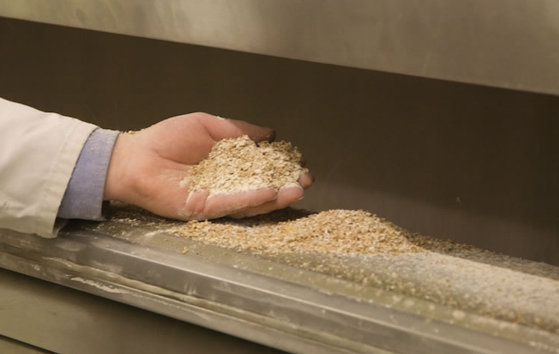
Milling: from grain to flour
Once a mill receives the grain, they can begin to turn it into flour. The grain is cleaned, then the grains are broken apart by ‘break rollers’. These split the grain into three portions: the germ, the bran and the endosperm. The endosperm is what is used to make white flour.
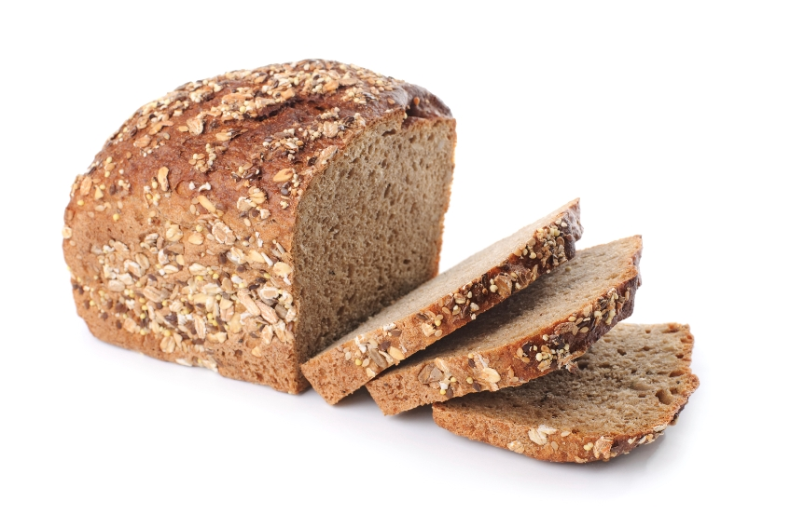
Uses of flour
After milling, flour can be made into a number of products, including breads, pastries, cakes, biscuits, pasta and more.

Milling: facts and figures

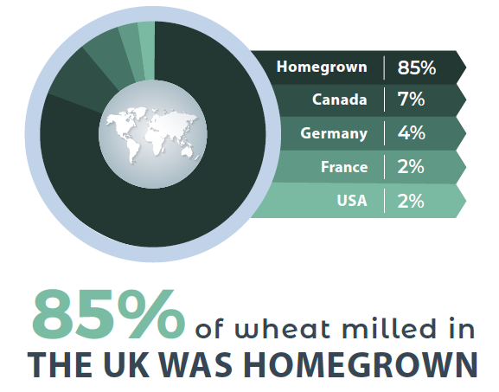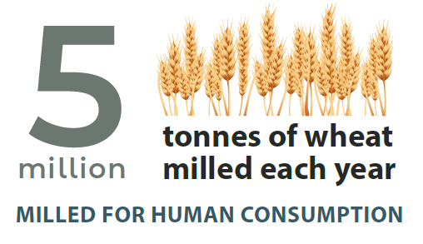

Type of flour milled: This shows the use of the different types of flour milled
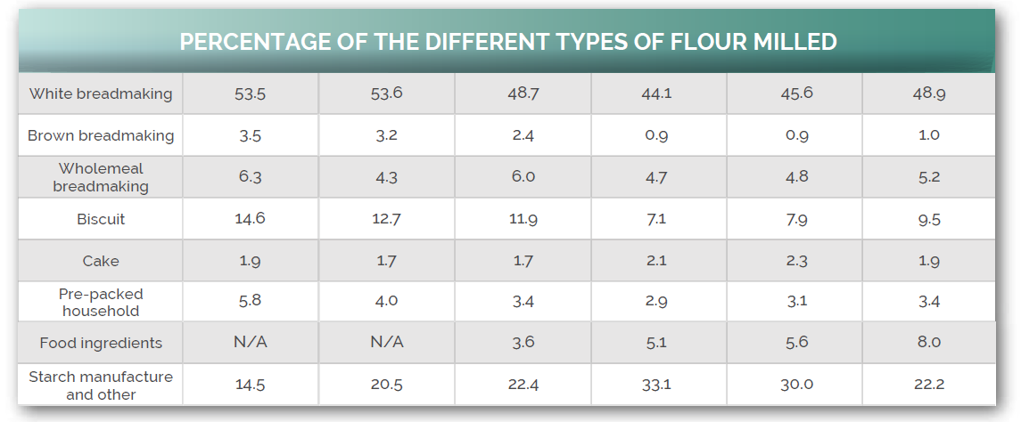

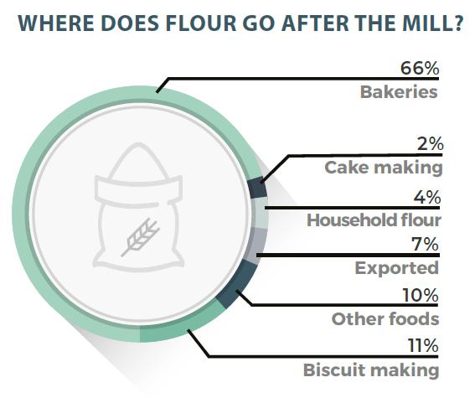
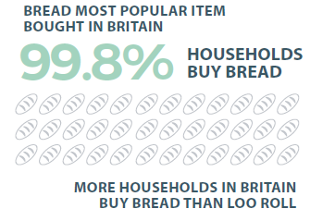
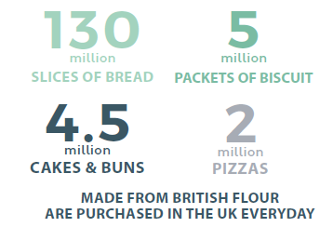
Classroom activities and resources

A range of resources have been created to support the teaching of harvest and harvest festival. The resources can be used individually, or used together to support more detailed topic work.

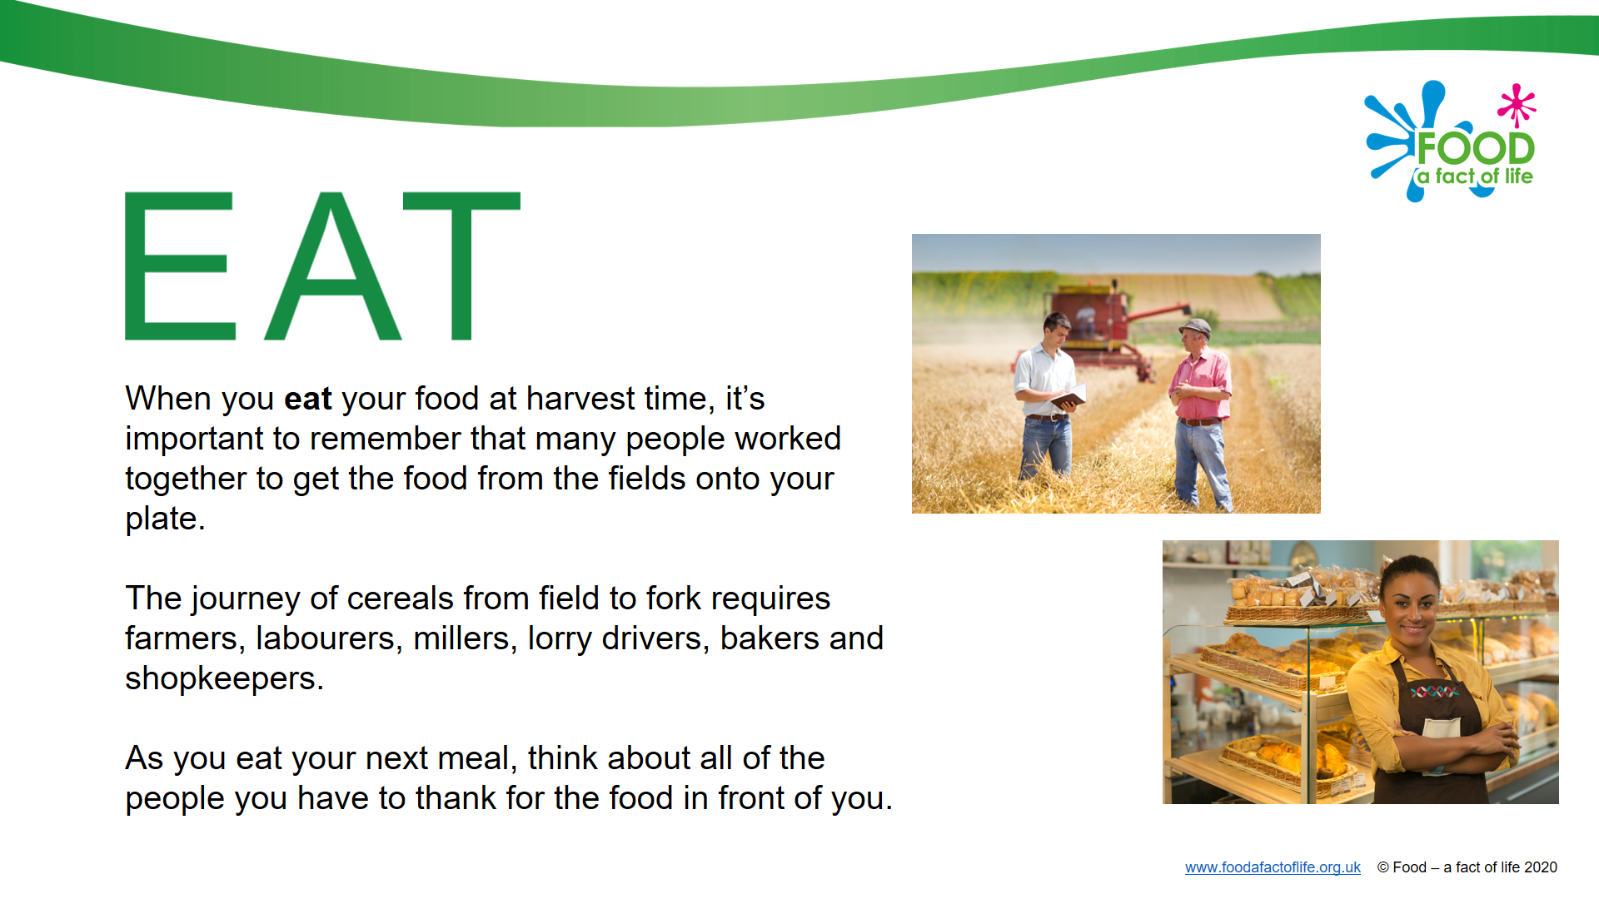
1) A harvest assembly

A presentation designed to be used as a ‘harvest’ assembly. It focuses on the harvest of wheat, and introduces harvest festival.

There are four interactive slides which used the word HARVEST to spell out the following words:
- EAT;
- REST;
- HAVE;
- SHARE.

These words can be used to highlight different social meanings of harvest, as well as the physical aspects of harvesting crops. The concept is for the words to be thought provoking for pupils. This may lead to other work, such as creating a harvest display, writing a song or exploring the harvesting of different crops.

This presentation could be amended to include the presentations highlighted in (2).

2) Harvest festival and the cereal harvest

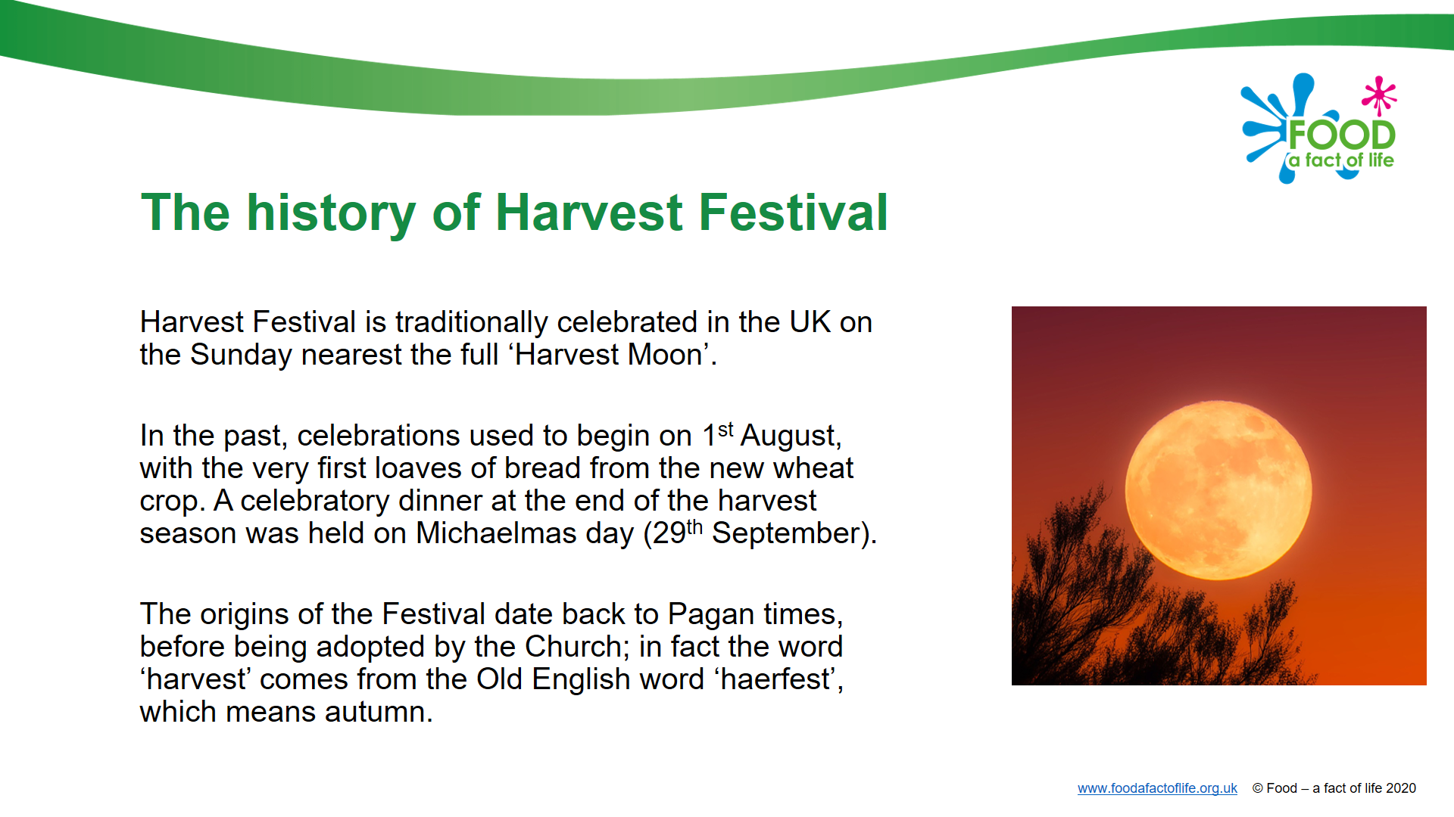
The harvest festival presentations sets out the history of the celebration, as well as explores its different traditions. Four key areas are highlighted: harvest loaves; songs; food baskets; and, corn dollies. These could be used as inspiration for classroom activities.

The presentation also explores the theme of harvest around the world, giving examples in the USA, Italy, China, Bali and the UK. This presentation could be combined with (1) A harvest assembly presentation.
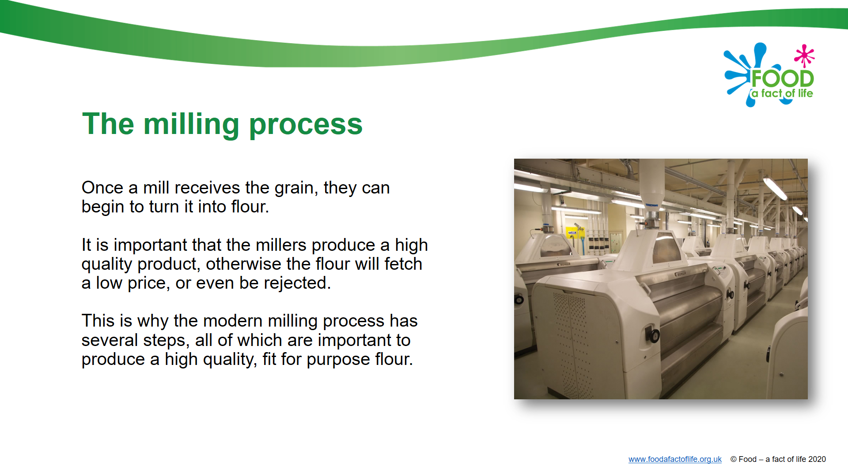
The cereal harvest presentation provides the story of wheat – from field to table. It goes through the main stages of planting, growing and harvesting wheat, then focusing on wheat being milled into flour. A number of ‘facts and figures’ are provided to give context for the scale of wheat production, milling and processing in the UK.

3) Quizzes
SCREEN IMAGE

Two online quizzes have been created to support learning around harvest festival and the cereal harvest. Each quiz comprises 10 multiple choice questions. On completion of the quiz, pupils receive a score – and if they score more than 7 out of 10, can download a certificate.

- Harvest festival: (LINK)
- Cereal harvest: (LINK)

4) Wheat harvest factsheet

A stand alone factsheet about wheat. This could be used as an extension activity while other pupils explore the cereal harvest or bake bread.

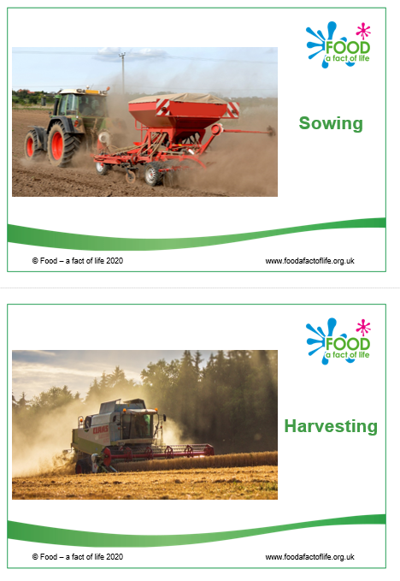
5) Field to bread – sequencing cards

A series of ten A5 cards that follow the cereal harvest: from field to table. The cards could be used in the following ways:
- Sequencing activity – following the cereal from field to table;
- Discussion cards – pupils to describe what is happening on the way, suggesting what happened before/after;
- Presentation cards – printed and presented as a frieze.

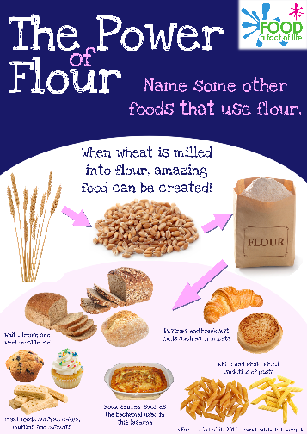
6) The power of flour poster

Use the poster to inspire pupils about the many different recipes and dishes that can be made with flour. You could ask pupils to create their own ‘power of flour’ poster. The poster can be used as inspiration to cook a variety of flour based recipes. For example, you could make:
- Bread (yeast based);
- Soda bread (quick to make and bake);
- Scones (fruit or cheese);
- Mini-pizzas.

To support, you could you bread-mixes or a bread machine in the classroom.

7) Practical activities, including cooking

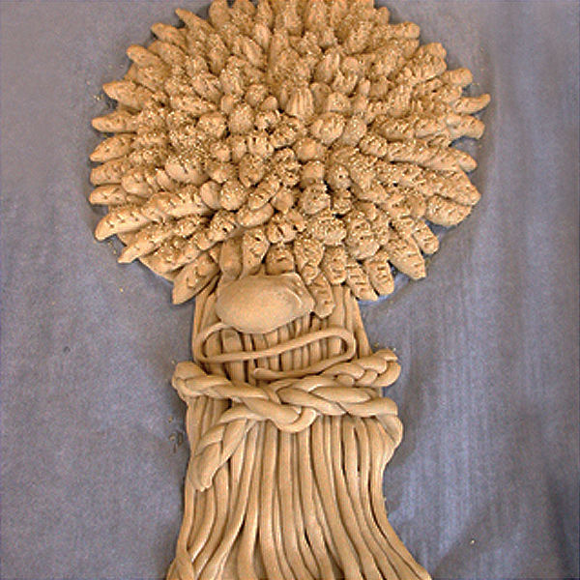
- Grow your own wheat

Details of how to grow your own wheat at school.

- Harvest loaf

A recipe and instructions for making a traditional harvest loaf.

- Harvest picture

A simple worksheet that challenges pupils to create a picture that represents ‘harvest festival’.

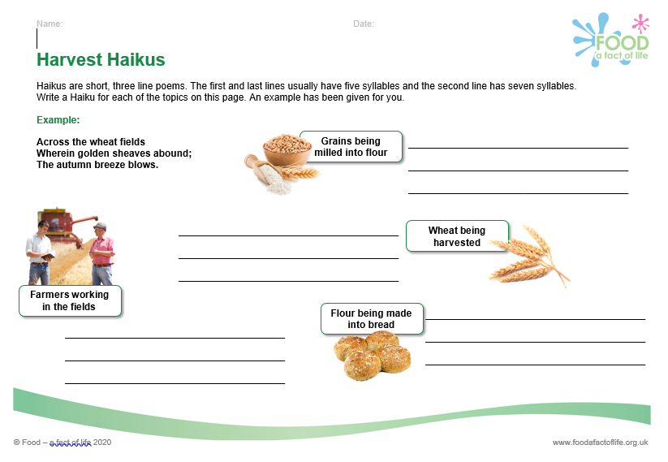
- Poems

Two worksheets that link the theme of harvest to poetry:
- Acrostic: using the ‘harvest’ letters;
- Haiku: a shirt, three link poem, focusing on famers, grains, milling and bread making.

- Cooking

There’s a huge range of recipes on the Food – a fact of life website - https://www.foodafactoflife.org.uk/recipes/.

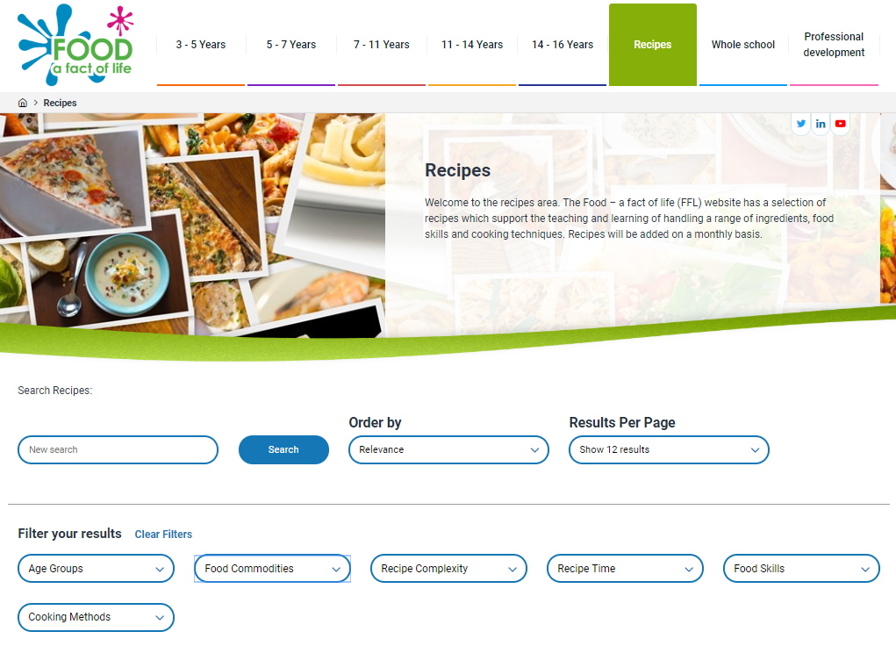
Recipes can be filtered by age, complexity, time, food skill, cooking method (e.g. baking) and food commodity (e.g. cereals, like flour).

Organise cooking sessions for your pupils, demonstrating how fibre can be increased. For example, why not bake different types of bread?

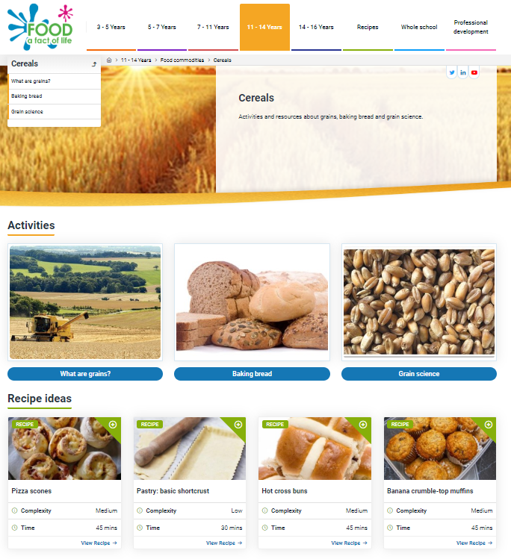
8) Where does food come from?

Explore where food comes food using the resources available on Food – a fact of life. For example, you could explore where cereals come from to extend learning:
- 5-7 Years
- 7-11 Years
- 11-14 Years
- 14-16 Years

