Eat more wholegrains ideas –
primary

Have a wholegrain option with at least one of your
main meals every day.

Eat more wholegrains worksheets for children

- Use the Wholegrain and non-wholegrain cards to get pupils to cut out the cards and sort into two piles, wholegrain and non-wholegrain foods.

Eat more wholegrains activities for children

- Get children to play the Wholegrain fibre line up activity and line up the selection of wholegrain cards from most to least amount of fibre they contain. The cards can be lined up by fibre per 100g or fibre per portion and all the information can be found on the cards.

Wholegrains at your school

- Challenge pupils to make a healthy wholegrain meal at school. Why not try some of the Food- a fact of life recipes, such as Hummus, pepper and grated carrot pockets, Savoury rice or Mini meatballs in tomato sauce?
- Question the class about their eating habits: Do you usually have brown pasta and rice with you meals? Do you like white or brown toast? What is your favourite type of breakfast cereal to have in the mornings?
- Hold a special breakfast event at school. Invite parents and carers into school to have a wholegrain breakfast with their children.
- Provide pupils with a copy of the wholegrain tracker worksheet so they can track their wholegrain consumption across a week.
- Pupils could research different wholegrain foods used in restaurants and cafés online and use these to plan a wholegrain only menu for an imaginary restaurant.
- Get pupils to research ‘wholegrains’ online. They could produce a presentation, display, leaflet or school website article to share with the class.

To find out more about wholegrains for children

- Information from BNF on starchy carbohydrate: https://bit.ly/31KfgXv

- Information from NHS on child nutrition: https://bit.ly/2ZNi2d8

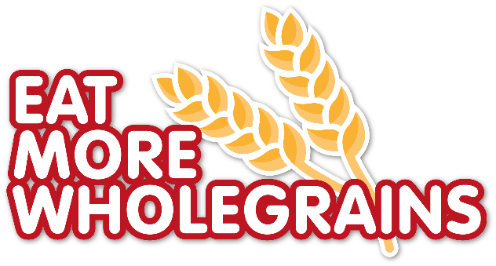
- Information from NHS on getting more fibre in the diet: https://bit.ly/2S83OBA

