Beat the PE teacher – Teachers’ notes
In this activity, pupils compete against the PE teacher at a number of activities. Pupils who manage to beat the PE teacher are announced at the celebration assembly and win a prize, e.g. an ‘I beat the PE teacher’ T-shirt.
Equipment:
- a PE teacher;
- sports equipment for three activities (this will vary depending on the activities you choose);
- scoresheet (provided in this pack);
- pen or pencil.

Instructions
- Decide what three activities will be used for the competition. A list of activity ideas is provided in this pack.
- Source the equipment for the activities.
- Set up the three activities near the ‘Beat the PE teacher’ stall and assign each activity with a number.
- To begin the activity, invite a pupil to compete against the PE teacher.
- Write the name of the pupil on the scoresheet.
- At the end of each activity, fill in the scoresheet, such as:
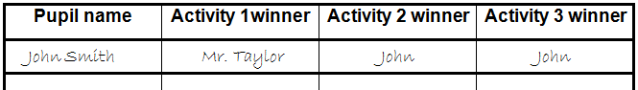

- If the pupil beats the PE teacher at all three of the activities, they can be rewarded a prize, e.g. a ‘I beat the PE teacher’ T-shirt, and a certificate at a celebration assembly.
- Repeat the activity with other pupils.

Beat the PE Teacher
Activity ideas

- How many netballs can you get through a hoop in one minute?

- How many star jumps can you do in one minute?

- How many keepy uppys can you do before you drop the ball?

- How fast can you complete an obstacle course?

- How long can you balance on one leg?

- How many goals can you score? (The teacher and pupil take it in turns to be the goalie)

Beat the PE teacher

Scoresheet
Pupil name | Activity 1 winner | Activity 2 winner | Activity 3 winner

